Provided by: George Belcher Evans & Wilmer

Introduction 5
FMLA Overview 6
Covered Employers 6
Private Sector Employer 6
Public Agency 7
Federal Government 7
Schools 7
Other Ways Employers May Be Covered Under the FMLA 7
Eligible Employees 8
12 Months of Employment 8
1,250 Hours of Service 9
50 Employees Within a 75-Miles Radius 9
Qualifying Reasons for FMLA Leave 10
Immediate Family Members 10
In Loco Parentis 11
Serious Health Condition 11
Managing the FMLA Process 13
Designation of FMLA Leave 13
Fitness-for-Duty Certification 14
Retroactive Designation of FMLA Leave 14
Notice Obligations 15
Employer Notice Obligations 15
Employee Notice Obligations 16
Certification Process 17
Scheduling and Taking FMLA Leave 19
Intermittent or Reduced-schedule Leave 19
Transfer to an Alternative Position 19
Spouses Working for the Same Employer 20
Calculating FMLA Leave 20
Increments of FMLA Leave 20
Substitution of Paid Leave 21
FMLA Leave and Other Paid Leaves 21
Unpaid Leave for Salaried Employees 22
Maintenance of Benefits 22
Group Health Plan 22
Multiemployer Health Plan 24
Benefits Other Than Health Insurance 24
Restoration 24
Light-duty Position 25
Limitations on Restoration Rights 25
Recordkeeping Requirements 25
Organizational Considerations 27
Operational Challenges 27
Manager Training 27
Automated Tracking Systems or Software 28
Vendor Outsourcing 28
Leveraging Technology 29
FMLA Leave Abuse 29
Employee Mental Health 30
Telemedicine 31
Remote Workers 31
Summary 31
Common Employer Questions 32
Summary 36
Appendix 37
Overview of the Family and Medical Leave Act Infographic 38
FMLA Glossary for Small Businesses 40
FMLA Guidelines 47
Complying with the FMLA Checklist 52
Federal Family and Medical Leave Policy 56
Employee Request Form for FMLA Leave 67
FMLA Leave Expiration Letter to Employees 68
Notice from Employee of Changes in Approved Family or Medical Leave 69

Introduction
Since its enactment in 1993, the Family and Medical Leave Act (FMLA) has been the bedrock of the U.S. Department of Labor’s (DOL) efforts to protect workers who need to take a prolonged absence due to a qualified family or medical reason. This law was enacted so employees could deal with serious and potentially unexpected life circumstances without losing their jobs. It was established on the principle that no worker in the United States should have to choose between their job and their health or that of their family. Since its enactment, workers have relied on the FMLA more than 100 million times to balance their employment demands with the needs of their and their families’ health.
The FMLA allows eligible employees of covered employers to take unpaid, job-protected leave for specified family and medical reasons. Employers can better support their workforce by recognizing situations where employees may need FMLA leave. In contrast, employers who do not comply with the FMLA can find themselves in difficult and costly legal situations. The DOL’s Wage and Hour Division (WHD) is authorized to investigate FMLA complaints. If employer violations cannot be satisfactorily resolved, the DOL may bring court action against the employer to compel compliance. An employee also may be able to initiate a private civil action against their employer for FMLA violations, which can be particularly costly, as they may involve paying back employees’ lost wages and reinstating benefits. At the start of 2022, the DOL announced an initiative to hire 100 additional WHD investigators, signaling a potential increase in enforcement in 2022 and beyond. This initiative means now is the time for employers to review their FMLA policies and practices to ensure they comply with all relevant laws.
Employers can use this HR Toolkit to help establish procedures and improve FMLA compliance. It provides an overview of the FMLA, including employer and employee requirements, and explores workplace strategies employers can implement to improve their internal FMLA processes. This toolkit also provides several valuable resources, but they are only a sampling of those that are offered. For additional FMLA-related resources, employers can contact George Belcher Evans & Wilmer.
By understanding the FMLA requirements detailed in this toolkit, employers can better support their workforce and avoid potential violations. In many situations, employees may be entitled to protections under other federal employment laws, state family and medical leave laws, and collective bargaining agreements. This HR Toolkit provides a broad overview of the FMLA and should not be construed as legal advice. Employers are encouraged to seek legal counsel to address specific concerns or issues.

FMLA Overview
Before addressing how organizations can best manage their FMLA processes, it’s valuable to understand an overview of the law. The FMLA is a federal law that provides eligible employees of covered employers with unpaid, job-protected leave for specified family and medical reasons. In addition to providing eligible employees with an entitlement to leave, the FMLA requires that employers maintain employees’ health benefits during leave and restore employees to their same or equivalent job positions after leave ends. The FMLA establishes employer and employee notice requirements and allows employers to request that employees certify their need for FMLA leave in certain circumstances. This section provides an overview of the FMLA, including covered employers, eligible employees and qualifying reasons for leave.
This HR Toolkit should not be construed as legal advice, and requirements may vary by state, so employers are encouraged to seek legal counsel to address specific issues and concerns. The information covered in this section comes from the DOL’s most current guidance for employers. Employers can find out more on the DOL’s website.

Covered Employers
The FMLA only applies to “covered” employers. A covered employer may be a private sector employer; a public agency, including state and federal employers; or a public or private elementary and secondary school. Covered employers must provide FMLA protections and benefits to eligible employees and comply with other responsibilities required by the law.

Private Sector Employer
A private sector employer is considered a covered employer by the FMLA if they employ 50 or more employees in 20 or more workweeks in the current or previous calendar year. An employee is considered employed each working day of the calendar week if the employee works any part of the week; workweeks do not have to be consecutive.
Employees who must be counted include:
- Any employee who works in the United States or any territory or possession of the United States
- Any employee whose name appears on payroll records, whether or not any compensation is received for the workweek
- Any employee on paid or unpaid leave, including FMLA leave, leaves of absences and disciplinary suspension, as long as there’s a reasonable expectation the employee will return to active employment
- Employees of foreign organizations operating in the United States
- Part-time, temporary, seasonal and full-time employees
Individuals who do not have to be counted include:
- Any employee with whom the employment relationship has ended, including employees who have been laid off
- Unpaid volunteers who do not appear on payroll records and do not meet the definition of an employee
- Employees of U.S. organizations stationed at worksites outside the United States or its territories or possessions
- Employees of foreign organizations operating outside the United States
Once an employer meets the requirements for FMLA coverage, they are a covered employer and remain so as long as they employ 50 or more employees in 20 or more workweeks in either the current or previous calendar year.

Public Agency
Public agencies are covered employers under the FMLA, regardless of the number of employees they employ. Public agencies include:
- The federal government
- The government of a state or political subdivision of a state
- An agency of the United States, a state or a political subdivision of a state, including counties, cities and towns, or any interstate government agency
The term “state” includes any U.S. state, the District of Columbia, and any U.S. territory or possession.

Federal Government
The Office of Personnel Management administers the FMLA for most federal employees. The WHD administers the FMLA for a limited number of federal employees, including employees of the following:
- The United States Postal Service
- The Postal Regulatory Commission
- The Federal Aviation Administration
- The judicial branch of the United States, in certain circumstances

Schools
Local educational agencies are covered under the FMLA regardless of the number of employees they employ. Education agencies include:
- Public school boards
- Public elementary and secondary schools
- Private elementary and secondary schools

Other Ways Employers May Be Covered Under the FMLA
In certain circumstances, employers that may not qualify to be covered under the FMLA may be required to comply with the law’s requirements. These situations include:
- Integrated employers—Separate organizations may be single employers under the FMLA if they are integrated employers. Factors determining whether organizations are integrated employers include common management, the interrelation between operations, the centralized control of labor relations, and the degree of common ownership or financial control.
- Joint employers—Where two or more organizations exercise control over an employee’s work or working conditions, they may be joint employers under the FMLA. When determining whether an employer is covered under the FMLA, employees jointly employed by multiple employers must be counted by each employer, even if the employees are maintained on only one of the employer’s payrolls.
- Successor employers—An employer may be a covered employer if it takes over the business operations (i.e., becomes a “successor in interest”) of a covered employer. Factors determining whether an employer is a successor in interest include continuing the same business operations, producing similar products or services, providing similar jobs or working conditions, continuing to use the same work force and supervisor structure, and using the same location and similar equipment or production methods.

Eligible Employees
The FMLA only applies to eligible employees. To be eligible, an employee must meet the following requirements:
- Be employed by a covered employer;
- Has worked for the employer for at least 12 months as of the date the FMLA leave is to start;
- Has at least 1,250 hours of service for the employer during the 12-month period before the leave; and
- Works at a location where the employer has at least 50 employees within a 75-mile radius.
These eligibility requirements are the same for all employees, regardless of the reason for the leave request. If an employee is not eligible for FMLA leave, the employer may grant the employee leave under the organization’s leave policy, but they may not designate the leave as FMLA even if the reason for leave would otherwise qualify under the FMLA.
Although public agencies and elementary and secondary schools are covered employers, regardless of the number of employees, employees of these employers must meet FMLA eligibility requirements to qualify for leave. Additionally, a public agency is generally treated as a single employer when determining employee eligibility. School employees who are under contract or employed permanently are considered to be on the payroll even during the time of the year when school is not in session.

12 Months of Employment
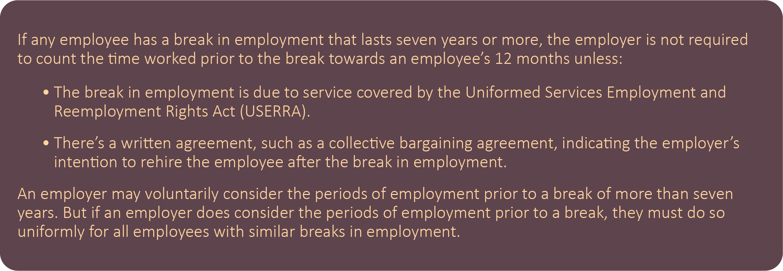
To qualify for FMLA leave, an employee’s 12 months of employment do not need to be consecutive. The FMLA allows employers to determine how to measure an employee’s annual entitlement to FMLA leave. For example, an employer may use a calendar year, any fixed 12-month period—such as a fiscal year or an employee’s anniversary date—or two different methods of measuring 12 months based on the employee’s personal leave record or requests. An employee’s part-time, temporary or season work generally counts towards the 12 months of employment requirement. If an employee is maintained on an employer’s payroll for any part of a week, that week counts as a week of employment.

1,250 Hours of Service
An employee meets the FMLA’s hours of service requirement if the employee has worked a total of 1,250 hours in the 12 months immediately preceding the start of the FMLA leave. For example, an employee only needs to work approximately 24 hours per week in the 12-month period to qualify for FMLA leave. Only the time an employee actually works counts towards the hours-of-service requirement, including overtime hours. Generally, the Fair Labor Standards Act’s (FLSA) principles for compensable hours are used to determine the hours of service an employee has worked for purposes of FMLA eligibility. An employee’s vacation, personal leave, sick leave, holidays and any other form of paid or unpaid time off does not count towards the 1,250 hours of service requirement. If an employer fails to maintain accurate time records of the hours an employee worked, the employer has the burden of showing that the employee has not met the hours-of-service requirement.
Employees returning from fulfilling USERRA-covered military service are credited with the hours of service they would have worked but for their military service. An employee’s pre-service work schedule can be used to determine the hours the employee would have worked during the period of their military service.

50 Employees Within a 75-Miles Radius
The number of employees on an employer’s payroll is used to determine the employee count, regardless of whether they are part-time, temporary or seasonal. The 75 miles are measured from the employee’s worksite by surface miles, using surface transportation over public streets, roads, highways and waterways by the shortest route possible.
A worksite is typically the location the employee reports to or from which the employee’s work is assigned. A worksite can be a single location, a group of buildings or separate facilities in geographic proximity to one another. If a covered employer has no worksites with at least 50 employees within the required 75-mile radius, none of its employees would be eligible for FMLA leave.
For FMLA purposes, an employee’s personal residence is not considered a worksite. Employees who work from home under telecommuting or flexi-place arrangements, or employees who may leave to work from and return to their residence—such as salespersons—the worksite is the office to which the employee reports or from which they receive assignments. For employees with no fixed worksite—such as construction and transportation workers or airline flight crews—their worksite is the location to which they report, from which their work is assigned or the location to which they are assigned as their home base.

Qualifying Reasons for FMLA Leave
An employee who meets FMLA eligibility requirements may take leave up to 12 workweeks of leave in a 12-month period for FMLA-qualify reasons. The following are qualifying reasons for FMLA leave:
- For the birth of a child or placement of a child with the employee for adoption or foster care and to bond with the newborn or newly placed child within one year of birth or placement
- For a serious health condition that results in the employee being unable to perform their essential job functions, including incapacity due to pregnancy, and prenatal medical care
- To care for the employee’s immediate family member who has a serious health condition, including incapacity due to pregnancy, and for their prenatal medical care
- For any qualifying exigency arising out of the fact that the employee’s immediate family member is a military member on covered active duty or called to covered active duty status

Immediate Family Members
An employee can take FMLA leave due to the serious health condition of an immediate family member. Under the FMLA, an immediate family member includes the following:
- Spouse—Spouse means a husband or wife as defined or recognized in the state where the employee was married, including common-law marriage, same-sex marriage or a marriage validly entered into outside of the United States. Same-sex spouses have the same leave rights as opposite-sex spouses under the FMLA.
- Parent—Parent means a biological, adoptive, step- or foster father or mother, or any other individual who stood in loco parentis to the employee when the employee was a child. A parent-in-law is not considered a “parent” for FMLA purposes.
- Son or daughter—Son or daughter means a biological, adoptive or foster child, stepchild, legal ward or a child of a person standing in loco parentis who is under 18 years of age.
A parent may take FMLA leave for a child who is 18 years of age and older if the child has a disability, as defined by the Americans with Disabilities Act (ADA), at the time the leave commences, is incapable of self-care because of their disability, or has a serious health condition and needs care because of their serious health condition.
Although not required, an employer may request that an employee provide reasonable documentation to establish their qualifying family relationship. An employee may provide either a statement stating a family relationship exists or other documentation, such as a child’s birth certificate or court document. The employee chooses whether to provide a statement or other documentation. Employers cannot use a request to confirm a family relationship in a way that interferes with an employee’s exercise or attempt to exercise their FMLA rights.

In Loco Parentis
An individual stands “in loco parentis” to a child if they have day-to-day responsibilities to care for or financially support the child. The individual is not required to have a biological or legal relationship with the child. If all other requirements are met, grandparents, siblings and other relatives may stand in loco parentis to a child under the FMLA. An in loco parentis relationship exists when an individual intends to take on the role of a parent.

Serious Health Condition
A serious health condition is an illness, injury, impairment, or physical or mental condition that involves inpatient care or continuing treatment by a health care provider. This may include conditions that involve an inpatient hospital stay or one or more visits to a health care provider and ongoing treatment. Chronic conditions, long-term or permanent periods of incapacity and certain conditions requiring multiple treatments may also meet FMLA requirements. The FMLA does not apply to routine medical examinations or common medical conditions unless complications develop.
When determining whether a serious health condition exists, the following requirements must be met:
- Inpatient care
This is an overnight stay in a hospital, hospice or residential care facility and includes any period of incapacity or any subsequent treatment in connection with the overnight stay.
- Continuing treatment by a health care provider
  - Incapacity plus treatment—This is a period of incapacity of more than three consecutive, full calendar days and any subsequent treatment period or period of incapacity relating to the same condition that involves:
    - Two or more in-person visits to a health care provider for treatment within 30 days of the first day of incapacity unless extenuating circumstances exist. The first visit must be within seven days of the first day of incapacity; or
    - One in-person visit, at least, to a health care provider for treatment within seven days of the first day of incapacity that results in continuing treatment under the supervision of a health care provider, such as a course of prescription medication or therapy requiring special equipment.

  - For any condition, “incapacity” means the inability to work, including being unable to perform any essential job function, attend school or perform regular daily activities due to, treatment of or recovery from a serious health condition. Treatment includes, but is not limited to, examinations to determine if a serious health condition exists and evaluations of the condition.
  - Pregnancy—This includes any period of incapacity due to pregnancy or for prenatal care.
  - Chronic conditions—This means any period of incapacity due to or treatment for a chronic serious health condition, such as diabetes, asthma and migraine headaches. A chronic serious health condition is one that requires visits to a health care provider at least twice a year and recurs over an extended period of time. A chronic condition may cause episodic periods of incapacity rather than a continuous period of incapacity.
  - Permanent or long-term conditions—This means a period of incapacity that is permanent or long-term due to a condition for which treatment may not be effective but requires continuing supervision of a health care provider, such as Alzheimer’s disease or the terminal stages of cancer.
  - Conditions requiring multiple treatments—This includes:
    - Restorative surgery after an accident or injury; or
    - A condition that would likely result in a period of incapacity of more than three consecutive, full calendar days if the employee or employee’s family member did not receive treatment.

Managing the FMLA Process
The FMLA permits eligible employees to take time off to attend to personal or family needs. This may seem straightforward, but many employers struggle with navigating the FMLA. Following FMLA requirements can be difficult and labor-intensive, and failing to precisely adhere to those requirements can expose employers to legal liabilities. FMLA violations can result in costly penalties for employers, including but not limited to the reimbursement of lost wages and benefits, liquidated damages, reinstatement of employment or duties, and reasonable attorneys’ fees and costs. This section aims to provide employers with important information to aid them in managing their FMLA processes and improving their compliance efforts. It explores FMLA-designated leave, notice obligations, the certification process, leave scheduling and calculation, the substitution of FMLA leave with paid leave, maintenance of benefits and job restoration.
The information covered in this section pulls from the DOL’s most current guidance for employers. Employers may consider consulting with an attorney to review their FMLA procedures and policies to ensure they comply with federal law.

Designation of FMLA Leave
Employers are responsible for designating an employee’s leave as FMLA-qualifying. Whether an employee’s leave is FMLA-qualifying must be based only on the information the employer receives from the employee. Once an employer designates an employee’s leave as FMLA leave, they must provide the employee with a Designation Notice within five business days. The Designation Notice informs the employee that their requested leave will be designated as FMLA leave and establishes any requirements while the employee is on leave. An employee’s medical certification often provides employers with sufficient information to determine whether an employee’s leave is FMLA-qualifying; however, if the employer has enough information to designate the employee’s leave as FMLA-qualifying immediately after receiving notice of the need for leave, they may provide the employee with the Designation Notice at that time.
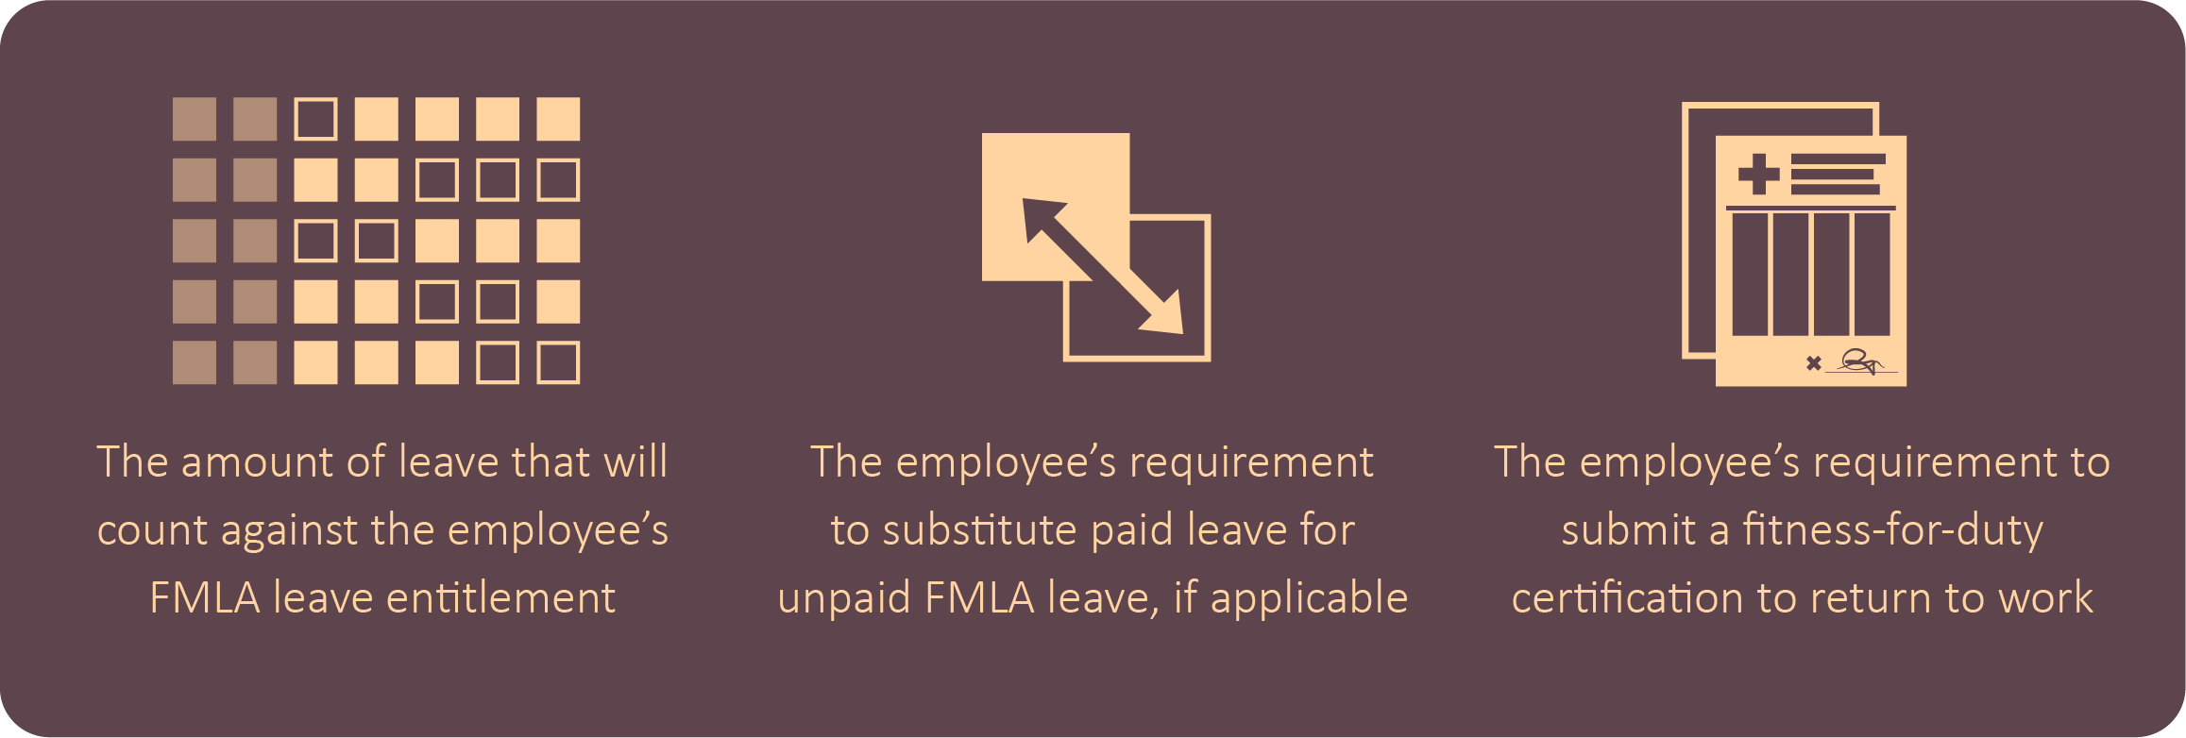
A written Designation Notice must include:
If the precise amount of employee leave is unknown at the time of designation, the employer needs to provide this information in writing upon the employee’s request.
If the employer does not have enough information to determine whether the employee’s reason for leave qualifies under the FMLA, the employer may ask the employee to provide additional information. This is known as a certification. If an employer cannot determine whether an employee’s leave request qualifies for FMLA protections due to incomplete or insufficient information provided by the employee, the employer must state in writing what additional information is needed to determine whether the employee’s leave is FMLA-qualifying. The employer may use the Designation Notice to inform the employee that their certification is incomplete or insufficient and identify what information is needed to make the certification complete and sufficient.
Employers only need to provide employees with one Designation Notice for each FMLA-qualifying reason in the 12-month year, regardless of whether the employee’s leave is continuous, intermittent or on a reduced schedule. However, if the information in the Designation Notice changes, the employer must notify the employee of the change in writing within five business days. An employer’s failure to timely provide the employee with the Designation Notice may be considered interference with, restraint or denial of the exercise of the employee’s FMLA rights.
Employers may use the DOL’s model Designation Notice (Form WH-382) available on the department’s website.

Fitness-for-Duty Certification
An employer may have a uniformly applied policy or practice that requires all similarly situated employees who take leave for their own serious health condition to submit a fitness-for-duty certification to return to work after an FMLA-qualifying leave. However, this certification can only be requested for the health condition that caused the employee’s need for FMLA leave. There are certain limitations that apply to the frequency an employer may request a fitness-for-duty certification for employee absences taken on an intermittent or reduced-schedule basis.
If an employer requires a fitness-for-duty certification to address an employee’s ability to perform the essential functions of their job, the employer must indicate this in the Designation Notice and provide the employee with a list of the essential functions of their job position. Employees are required to pay the costs associated with a fitness-for-duty certification. An employer may delay restoring an employee to their position until the employee submits a fitness-for-duty certification. An employer may also contact the employee’s health care provider to authenticate or clarify the certification; however, the employer may not delay the employee’s return to work while contacting the health care provider, and the employer may not require second or third opinions.
Separate from an employer’s ability to request a fitness-for-duty certification, an employer may require an employee to submit to an examination by the employer’s medical staff at the employer’s expense as long as the examination is job-related and consistent with business necessity. An employer may not deny or delay reinstating an employee returning from FMLA leave pending an examination by the employer’s medical staff.

Retroactive Designation of FMLA Leave
An employer may retroactively designate an employee’s absence as FMLA leave if it fails to timely designate the leave. The employer must provide the employee with appropriate notice, and the retroactive designation cannot harm or injure the employee. An employer and employee can mutually agree that leave be retroactively designated as FMLA leave. If an employer’s failure to timely designate FMLA leave harms or injures the employee, the employer may be liable for damages or be required to take remedial actions.

Notice Obligations
Effective communication is critical at all stages of the FMLA process. It is also a key component of successfully administering an organization’s FMLA policies and procedures. This is especially critical because employees do not have to specifically request or mention FMLA leave to be entitled to it.

Employer Notice Obligations
Every covered employer must provide a general notice to their employees regarding the FMLA. To satisfy this requirement, employers must display or post a general notice, also referred to as a poster, and provide a written general notice to employees if they have any FMLA-eligible employees.
- Posting requirement—Covered employers must display or post an FMLA general notice. This poster must be displayed in plain view where all applicants and employees can see it, and it must have large enough text to be easily read. The information displayed on the poster must explain the FMLA provisions and provide information on filing a complaint with the WHD. Employers must display a poster even if no employees are currently eligible for FMLA leave. If a significant portion of an employer’s employees does not read or write English, the employer must provide the FMLA general notice in a language they can read and write. Employers must also comply with all applicable requirements under federal and state law for individuals with sensory impairments.
- General notice requirement—In addition to the posting requirement, if a covered employer has any FMLA-eligible employees, it must provide each employee with a general notice about the FMLA in the employer’s employee handbook or other written materials about leave and benefits. If the employer does not have a handbook or written leave materials, it must distribute a general notice to each new employee upon hire. This general notice requirement can be met by copying the general notice language found on the DOL’s FLMA poster. Employers may distribute the general notice electronically.
Employers who willfully violate the FMLA’s posting requirement may be subject to a civil penalty for each violation. Employers may use the DOL’s free poster, which can be found on the department’s website.
In addition, after an employer determines an employee is eligible for FMLA, the employer must provide the employee with an Eligibility Notice and a Rights and Responsibilities Notice.
- Eligibility Notice—This notice may be oral or in writing and must inform the employee whether they are eligible for FMLA leave. The employer must provide the employee with the Eligibility Notice within five business days of the employee’s initial request for leave or of learning that the employee’s leave may be for an FMLA-qualifying reason unless there are extenuating circumstances. The employer also must provide the Eligibility Notice the first time an employee takes leave for FMLA-qualifying reasons in the designated 12-month leave year. Employers are not required to provide a new Eligibility Notice for FMLA absences for the same qualifying reason during the same leave year or for a different reason where the employee’s eligibility status has not changed.
- Rights and Responsibilities Notice—This notice provides the employee with specific expectations and obligations relating to their FMLA leave. An employer must provide a written Rights and Responsibilities Notice each time it provides an eligible employee with the Eligibility Notice, and it must do so within five business days of having notice of the employee’s need for leave. Employers are expected to be responsive to employee questions regarding their rights and responsibilities under the FMLA. If the employee is already on leave, the employer should mail the Rights and Responsibilities Notices to the employee’s address of record. This notice must be in writing and include the following information:
  - A statement of the period of leave that may be designated and counted against the employee’s FMLA leave entitlement
  - The 12-month period used to track the employee’s FMLA leave usage
  - The employee’s requirement to provide certification of their need for leave, if applicable
  - The employee’s right to use paid leave; whether the employer will require the substitution of paid leave, including any conditions related to the substitution; and the employee’s rights to take unpaid FMLA leave if the employee does not meet the conditions for paid leave
  - The employee’s status as a “key employee” and potential restoration consequences
  - The employee’s right to job restoration and maintenance of benefits
  - The employee’s requirement to make premium payments to maintain health benefits and any arrangements for doing so, the consequences of failing to make payments on a timely basis and the employee’s potential liability for premium payments made by the employer if the employee fails to return to work, if applicable
  - The consequences of an employee’s failure to meet their obligations
Failure to timely notify employees of their eligibility for FMLA leave may constitute interference with, restraint or denial of the exercise of an employee’s FMLA rights. This can expose employers to liability. If an employer determines an employee is not eligible for FMLA leave, it must provide at least one reason why the employee is not eligible in the Eligibility Notice.
If a significant portion of the employer’s workforce is not literate in English, the employer must provide the Eligibility Notice and Rights and Responsibilities Notice in a language in which employees are literate. Employers may combine the Eligibility Notice and Rights and Responsibility Notice or provide them to employees at the same time. Employers can use the DOL’s model Notice of Eligibility and Rights and Responsibilities form (Form WH-381) or create their own version containing the same basic information.

Employee Notice Obligations
An employee must provide their employer with notice of their need for FMLA leave. An employer may require employees to comply with its usual policies for requesting leave unless the circumstances related to the employee’s need for leave prevent the employee from doing so. If an employee fails to follow their employer’s policies for requesting leave, an employer may take action under its internal rules and procedures related to the employee’s leave request. Employers can, however, waive the employee’s notice requirement or their own internal policies regarding leave requests but cannot discriminate against employees for taking FMLA leave.
An employee’s notice may be oral or written. The first time the employee requests FMLA leave for a qualifying reason, they are not required to specifically mention the FMLA. The employee only needs to provide enough information for the employer to understand that the leave may be covered by the FMLA. If the leave is foreseeable, the employee needs to indicate when and how much leave is needed. Once an employee is approved for FMLA leave, if additional leave is needed for the same reason, the employee may be required to reference the FMLA or the reason for additional leave. In every situation, employers may ask additional questions to determine if an employee’s leave is FMLA-qualifying.
When an employee’s need for FMLA leave is foreseeable, the employee typically must give notice at least 30 days in advance if it’s possible and practical to do so. If an employee does not provide at least 30 days’ advance notice—and it is possible and practical to do so—the employer may delay the FMLA leave until 30 days after the date that the employee provides notice. If 30 days’ advance notice is not possible or the need for leave is unexpected, the employee must provide notice of the need for leave as soon as possible and practical. For planned medical treatment, an employee needs to consult with their employer and try to schedule the treatment at a time that minimizes disruption to the employer’s operations.
When an individual needs to take FMLA leave for a qualifying exigency of a military family member, an employee must give notice of the need for leave as soon as possible and practice, regardless of how far in advance the leave is needed. The DOL’s guide provides employers with additional information regarding Military Family Leave under the FMLA.

Certification Process
In certain circumstances, an employer may require that an employee submit a certification to support their need for FMLA leave. A certification is a document or form that is completed by the employee and, as appropriate, a health care provider. The certification allows employers to obtain information related to an employee’s FMLA leave request, including the likely periods of absences, and verify that the employee or their family member has a serious health condition. An employee must provide the initial certification if their employer requests it, including finding a health care provider to complete the certification and paying the costs associated with the certification. If the employee does not provide the certification, the employer may deny the employee’s request for FMLA leave.
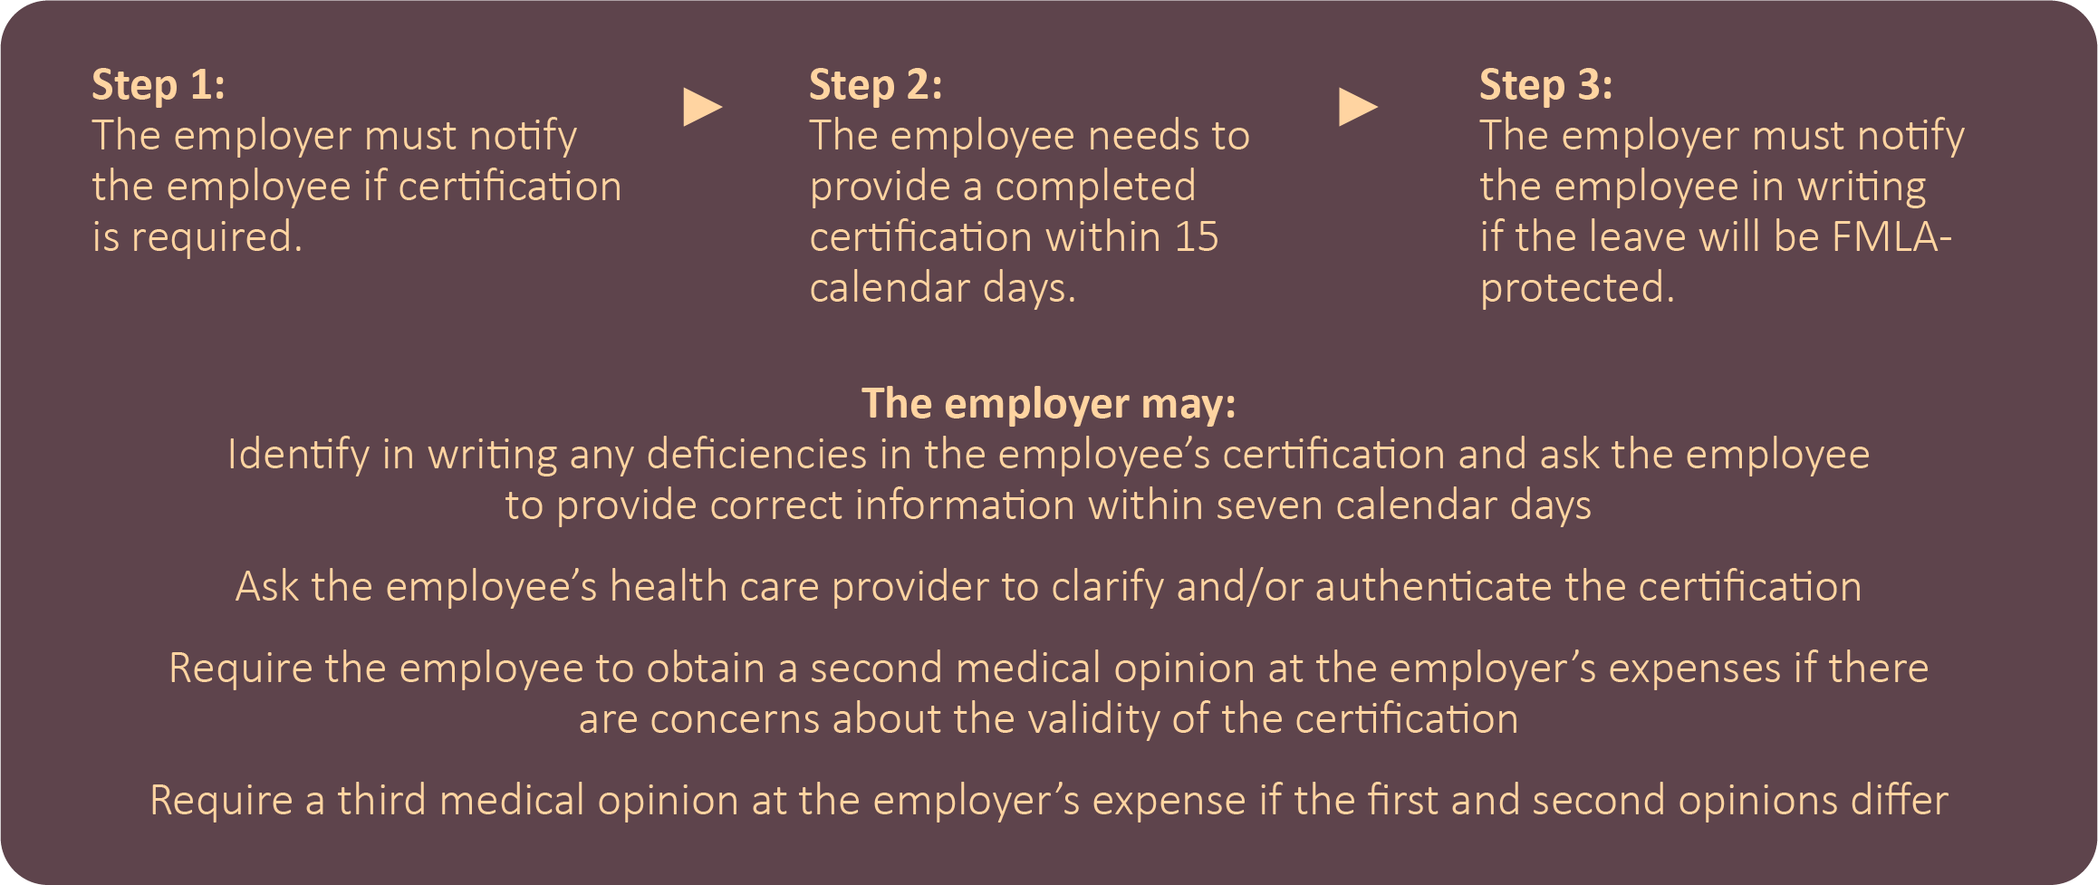
An employer’s notice that a medical certification is required must be included in the written Rights and Responsibilities Notice. In some cases, an employer may request certification at a later date if they have reason to question the appropriateness of the employee’s leave or its duration. Employers may not request a certification for leave to bond with a newborn child or a child placed for adoption or foster care; however, employers may request documentation to confirm the employee’s family relationship in those situations.
The information requested in the certification may relate only to the serious health condition for which the employee is seeking leave. To be considered complete and sufficient, the certification needs to include the health care provider’s contact information; when the serious health condition started; how long the serious health condition is expected to last; whether the employee is unable to work as well as the likely duration of the employee’s inability (if the employee is the patient); whether the employee’s need for leave is continuous or intermittent; and appropriate medical facts about the health condition. If the employee’s family member is the patient, the certification needs to include whether the family member needs care and an estimate of the frequency and duration of the leave required to care for the family member.
For purposes of an FMLA certification, a health care provider is:
- A doctor of medicine or osteopathy authorized to practice medicine or surgery by the state in which the doctor practices
- A podiatrist, dentist, clinical psychologist, optometrist or chiropractor authorized to practice in the state and performing within the scope of their practice
- A nurse practitioner authorized to practice in the state and performing within the scope of their practice
- A Christian Science practitioner listed with the First Church of Christ, Scientist, in Boston, Massachusetts
- Any health care provider from whom the employer or the employer’s group health plan’s benefits manager will accept a medical certification to substantiate a claim for benefits
Employers are not required to use a specific certification form. Employers can use the DOL’s model certification forms available on the department’s website.

Scheduling and Taking FMLA Leave
FMLA leave is taken in a defined 12-month period, also known as the “leave year.” If an employee’s need for FMLA leave extends beyond the 12-month leave year, any additional time the employee requests will count against the employee’s FMLA leave entitlement for the next leave year.
Employers may use one of the following methods for determining the 12-month period:
- The calendar year
- Any fixed 12 months, such as an employer’s fiscal year or a leave year starting on the employee’s first day of employment
- A 12-month period measured forward from the first date an employee takes FMLA leave
- A rolling 12-month period measured backward from the date an employee uses FMLA leave
Whatever method an employer uses, it must apply it uniformly and consistently to all employees; however, multistate employers with eligible employees in a state with a state family and medical leave law that requires a specific method for determining the 12-month leave period may use the state provision for all employees within that state. Employers may change their methods for determining the 12-month period only after providing 60 days’ notice to all employees. During the transition to the new method, employers must retain the full benefit of 12 workweeks of leave under whichever method provides the most benefit to employees.

Intermittent or Reduced-schedule Leave
Employees may take FMLA on an intermittent or reduced-schedule basis. Employers must allow employees to take intermittent or reduced-schedule FMLA leave when there’s a medical need for it. Employees may take intermittent or reduced-schedule leave for their own serious health condition, to care for a qualifying family member with a serious health condition or to care for a covered servicemember with a serious injury or illness. Employees may also use intermittent and reduced-schedule FMLA leave for qualifying exigencies. Intermittent leave is not permitted for the birth of a child, to care for a newborn, or for the placement of an adopted or foster child unless the employer agrees to allow it.
An employee using intermittent or reduced-schedule FMLA leave for planned medical treatment, either for their own serious health condition or that of a qualifying family member, must make a reasonable effort to schedule the treatment so as not to unduly disrupt an employer’s operations.

Transfer to an Alternative Position
Employees needing intermittent or reduced-schedule FMLA leave for a foreseeable, planned medical treatment may be temporarily transferred to an alternative position that better accommodates recurring periods of leave. If an employer transfers an employee to an alternative position to accommodate their recurring periods of FMLA leave, it must provide the employee with pay and benefits equivalent to those the employee had in their position prior to the transfer. However, the new position does not need to be equivalent in duties. When an employee no longer needs intermittent or reduced-schedule FMLA leave, the employer must restore the employee to the same or equivalent job as the job the employee left when their FMLA started.

Spouses Working for the Same Employer
Eligible spouses working for the same employer are limited to a total of 12 workweeks of leave in a 12-month period for the birth of a new child, the placement of an adopted or foster child, and to care for a parent with a serious health condition. This only applies to employees who are legally married, even if the two unmarried employees live together or have a child together. These limitations apply even if the spouses are employed at different locations that are more than 75 miles apart. If only one spouse is eligible for FMLA leave, that individual is entitled to the full 12 workweeks of leave.
These limitations do not apply to leave for one’s own serious health condition, including the recovery period following the birth of a child, to care for a qualifying family member with a serious health condition and for any qualifying exigency arising from a qualifying family member who is a military member on active duty.

Calculating FMLA Leave
The time an employee is not rescheduled to report to work may not be counted as FMLA leave. Only the amount of leave an employee actually takes may be counted against their FMLA leave entitlement. When a holiday falls during a week in which an employee is taking a full week of FMLA leave, the entire week is counted as FMLA leave. When a holiday falls during a week in which an employee is taking less than a full week of FMLA leave, the holiday is not counted as FMLA leave unless the employee was scheduled and expected to work on the holiday and used FMLA leave that day.
If an employer temporarily stops business activities and employees are not expected to report to work for one or more weeks, the period of time that the employer’s business activities have stopped does not count against an employee’s FMLA leave entitlement.

Increments of FMLA Leave
Employees do not accrue FMLA leave at any particular hourly rate.
Eligible employees may take FMLA leave in periods of weeks, days, hours and, in some cases, less than an hour; however, employees may not perform any work during any period of time counted as FMLA leave. The total number of hours an eligible employee is entitled to take on an intermittent or reduced-schedule basis depends on the specific hours the employee would have worked had the employee not taken FMLA leave. When an employee takes less than one full workweek of leave, the amount of FMLA leave used is determined as a proportion of the employee’s actual workweek. Employers may convert fractions of a workweek into their hourly equivalent as long as the conversion fairly reflects the employee’s total hours.
If an employee’s schedule varies from week to week so that it’s not possible to determine how many hours the employee would have worked during the week had they not taken FMLA leave, an employer may use a weekly average to calculate the employee’s FMLA leave entitlement. This weekly average is calculated by using the employee’s scheduled hours from the 12 months prior to the start of the leave, including any hours the employee took for any type of leave.
If an employee normally works overtime but is unable to do so because of an FMLA-qualifying reason, the overtime hours that the employee would have been required to work may be counted against the employee’s FMLA entitlement. Voluntary overtime hours an employee does not work due to an FMLA-qualifying reason may not be counted against the employee’s FMLA leave entitlement.
Employees may use FMLA leave in the smallest time increment the employer allows for other forms of leave, as long as the smallest increment is no more than one hour. If an employer uses different increments for different types of leave, the employer must allow employees to use FMLA leave in the smallest increment used for any type of leave. If an employer allows or requires employees to use leave in different increments during specific times of the day, employees may use the same increment for FMLA leave at those specific times of the day. Employers may allow employees to use FMLA leave in shorter increments than used for other forms of leave.
If it’s physically impossible for employees using intermittent or reduced-schedule leave to begin or end work midway through a shift, the entire period that the employee is forced to be absent is designated as FMLA leave and counts against the employee’s leave entitlement. This only applies when it is truly impossible to return to work after an FMLA absence.

Substitution of Paid Leave
Eligible employees may choose or employers may require employees to substitute accrued paid leave for FMLA leave. This means that accrued paid leave runs concurrently with unpaid FMLA leave. An employee’s ability to substitute accrued paid leave for FMLA leave is determined by the employer’s normal leave policy. When employees use paid leave for an FMLA-covered reason, that leave is FMLA-protected. Employees receive pay according to their employer’s applicable paid leave policy.
In order to substitute accrued paid leave for FMLA leave, an employee must have both earned the leave and is able to use that leave during the FMLA leave period. Employers cannot require employees to substitute leave that is not yet accrued or available; however, they may voluntarily advance paid leave to employees and employees may voluntarily accept the leave during an FMLA absence.
When accrued paid leave is substituted for FMLA leave, either at the employee’s or the employer’s choosing, the employer must inform the employee of any procedural requirements of its paid leave policy that the employee needs to satisfy in the Rights and Responsibilities Notice. An employee’s failure to comply with the employer’s procedural requirements may result in not being entitled to substitute accrued paid leave. This does not, however, impact the employee’s entitlement to FMLA leave. If an employer’s policy for using paid leave requires a doctor’s note for each absence, the employee using paid leave concurrently with FMLA leave must provide a doctor’s note for each absence to receive the paid leave. If the employee does not provide a doctor’s note, the employee is still entitled to unpaid FMLA leave.

FMLA Leave and Other Paid Leaves
Leave taken under workers’ compensation or a disability leave plan may also qualify for FMLA leave for an employee’s own serious health condition. Consequently, employers may require employees to take FMLA leave concurrently with leave taken under workers’ compensation or a disability leave plan. When leave under workers’ compensation or a disability leave plan runs concurrently with FMLA leave, employers cannot require employees to substitute accrued paid leave since leave under workers’ compensation or a disability leave plan is not unpaid. Where state law allows, employers and employees may agree to have accrued paid leave supplement workers’ compensation or disability leave plan benefits. For example, if a short-term disability plan only replaces two-thirds of an employee’s salary, the employee and their employer, when permitted, can agree to supplement the remaining one-third with accrued paid leave.

Unpaid Leave for Salaried Employees
Exempt employees under the FLSA do not lose their FLSA exemption by receiving unpaid FMLA leave. An employer may make deductions from an exempt employee’s salary for any hours taken as intermittent or reduced-schedule FMLA leave within a workweek without affecting the employee’s exempt status.
Employees paid according to the FLSA’s fluctuating workweek method for paying overtime may be paid on an hourly basis only for the hours the employee works, including time and one-half of the employee’s regular rate of pay for any overtime hours worked, during the period in which intermittent or reduced-schedule FMLA leave is scheduled to be taken. This payment change to an hourly basis must include the entire period during which the employee is taking intermittent leave, including the weeks in which the employee takes no FMLA leave.

Maintenance of Benefits
Employees who exercise their FMLA leave rights cannot lose any employment benefits accrued before the start of their leave.

Group Health Plan
During any FMLA leave, an employer must maintain the employee’s coverage under any group health plan on the same terms that would have been provided if the employee had been continuously employed during the entire leave period. All covered employers under the FMLA are subject to this requirement. Employees must continue to make any normal contributions to the costs of their health insurance premiums while on FMLA leave. This also applies to supplement benefits to an employer’s group health plan.
Under the FMLA, a group health plan means any employer plan, including a self-insured plan, that provides health care to employees, former employees or their families. This includes plans contributed to by employers. A group health plan does not include an insurance program providing health coverage under which employees purchase individual policies from insurers, provided that:
- No contributions are made by the employer.
- An employee’s participation in the program is completely voluntary.
- The employer’s sole functions as it pertains to the program are to permit the insurer to publicize the program to employees, collect premiums through payroll deductions and remit premiums to the insurer.
- The employer receives no consideration in connection with the program other than reasonable compensation, excluding any profit, for administrative services actually performed in connection with payroll deductions.
- The premium charged with respect to such coverage does not increase in the event the employment relationship ends.
If an employer provides a new health plan or benefits, or the health plan or benefits change while an employee is on FMLA leave, the employee is entitled to the new or changed health plan or benefits to the same extent as if the employee was not on leave. An employer must provide the employee with a notice of any opportunity to change health plans or benefits while on FMLA leave, including during an employer’s open enrollment period.
Employees may choose not to retain group health plan coverage during FMLA leave. When an employee returns from leave, however, the employee is entitled to be reinstated on the same terms as prior to taking leave without any qualifying period, physical examination or exclusion of preexisting conditions.
If paid leave is substituted for FMLA leave, the employee’s group health plan premiums must be paid by the method normally used during paid leave. This is typically through payroll deductions. An employee on unpaid FMLA leave needs to make arrangements to pay their normal group health plan premiums to maintain insurance coverage. If an employee’s premium payment is more than 30 days late, the employer may terminate the employee’s coverage unless the employer has a policy allowing a longer grace period. An employer must provide written notice to the employee that their premium payment has not been received and allow at least 15 days after the date of the notice before stopping coverage.
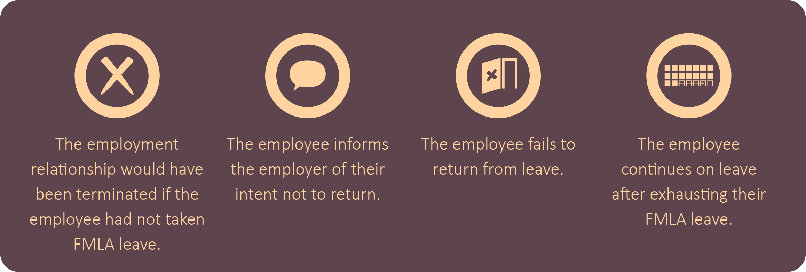
Except as required by the Consolidated Omnibus Budget Reconciliation Act of 1986 (COBRA) and for “key employees,” an employer’s obligation to maintain health benefits during leave ceases only if and when:
An employer may choose to pay the employee’s portion of the premium to ensure that the employee will receive equivalent benefits upon their return from FMLA leave. In those situations, the employer may require the employee to repay the premium amounts paid by the employer. In addition, an employer may require an employee to repay the employer’s share of premium payments if the employee does not return to work following their FMLA leave, unless the employee does not return because of circumstances beyond the employee’s control, including for an FMLA-qualifying medical condition.

Multiemployer Health Plan
A multiemployer health plan is where more than one employer is required to contribute, and the plan is maintained pursuant to one or more collective bargaining agreements between employee organizations and employers. An employer under a multiemployer health plan must continue to make contributions on behalf of an employee using FMLA leave as though the employee had not taken leave unless the plan contains an explicit FMLA provision for maintaining coverage.
During the duration of an employee’s FMLA leave, coverage by the group health plan and benefits provided must be maintained at the level of coverage and benefits at the time the employee’s leave began. An employee using FMLA leave cannot be required to pay a greater premium than if leave had not been taken.

Benefits Other Than Health Insurance
An employee’s right to benefits other than group health insurance while on FMLA leave depends on their employer’s established policies. Any benefits that would be maintained while the employee is on other forms of leave, including paid leave if the employee substitutes accrued paid leave during FMLA leave, must be maintained while the employee is on FMLA leave.

Restoration
When an employee returns from FMLA leave, an employer must restore the employee to the same job the employee held when the leave started or to an equivalent job. An employee, however, is not guaranteed the actual job they held prior to the leave.
Equivalent pay includes the same or equivalent pay premiums, such as shift differentials, and the same opportunity for overtime premium pay as the job the employee held prior to FMLA leave. Employees are entitled to any unconditional pay increase that occurred while the employee was on FMLA leave, such as cost-of-living increases, bonuses or other payments. If a bonus is conditioned on achieving a specific goal, such as hours worked or products sold, and the employee does not meet the goal due to their FMLA leave, employers do not have to pay the employee the bonus unless the employer pays it to employees taking the same type of leave for a non-FMLA reason. If the employer pays the bonus to employees taking leave for a non-FMLA reason, it must also pay the bonus to an employee taking FMLA leave. Additionally, an employee is entitled to pay increases conditioned on seniority, length of service or work performed if employees taking the same type of leave for non-FMLA reasons receive the increases.
When an employee returns from FMLA leave, an employer must make available any benefits the employee accrued prior to the leave. These benefits must be resumed in the same manner and at the same level as when the employee’s leave started, subject to any changes in benefit levels affecting all employees. An employer cannot require an employee returning from FMLA leave to requalify for any benefits the employee enjoyed prior to their FMLA leave.

Light-duty Position
An employer may offer an employee a light-duty position when the employee makes a request for FMLA leave. The employee, however, is not required to accept the position rather than take leave. The employee may reject the light-duty position and continue on FMLA leave until they are able to return to the same or equivalent job the employee left or until their FMLA leave entitlement is exhausted.
When an employee voluntarily accepts a light-duty position instead of taking FMLA leave, the time the employee works in the light-duty position does not count as FMLA leave. The employee also has the right to be restored to the same or equivalent position the employee previously held prior to the light duty, as long as the employee is able to perform the essential functions of the position. The employee’s right to restoration while on light duty expires at the end of the 12-month leave year.

Limitations on Restoration Rights
An employee on FMLA leave is not protected from actions that would have affected them if they were not on leave. An employer may also deny a key employee their right to return to work if needed to prevent substantial and grievous economic injury to the employer’s operations. A key employee is a salaried employee who is among the highest-paid 10% of all employees within 75 miles of the worksite.

Recordkeeping Requirements
Covered employers subject to the FMLA are required to make, keep and preserve certain records. Employers do not need to retain the records in any particular form, but they must keep them for at least three years. Employers do not need to submit the records to the DOL unless requested, and they need to make these records available for inspection, copying and transcription upon request by representatives of the DOL.
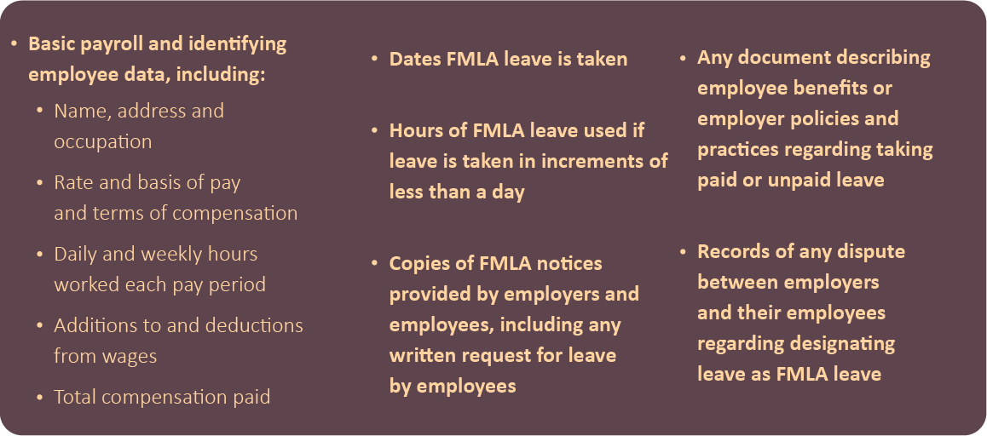
Covered employers who employ FMLA-eligible employees must maintain the following records:

Covered employers who are not subject to the FLSA’s recordkeeping requirements for minimum wage and overtime compliance but have FMLA-eligible employees do not need to maintain records of actual hours worked provided that:
- FMLA leave eligibility is presumed for any employee who has been employed for at least 12 months.
- For employees who take FMLA leave intermittently or on a reduced schedule, the employer and employee agree on the employee’s normal schedule or average hours worked each week, memorialize the agreement in writing and maintain the agreement in accordance with the FMLA’s record requirements.
Covered employers with no FMLA-eligible employees only need to maintain basic payroll records and identifying employee data.
Employers must maintain records and documents relating to FMLA medical certifications and recertifications of employees and their family members as confidential medical records. These records need to be maintained separately from personnel files. These records also need to be maintained in accordance with the confidentiality requirements of other laws, such as the ADA and the Genetic Information Nondiscrimination Act. However, supervisors and managers may be informed of an employee’s work duty restrictions and accommodations.

Organizational Considerations
The FMLA appears deceptively simple, and as a result, employers may not prioritize the leave process appropriately. However, complying with the FMLA leave requirements can be challenging and time-consuming, especially as employees’ medical issues and treatments are becoming more complex. Most employers must address ongoing challenges, like manager training, leave management and legal compliance, which is becoming more complicated as more states and localities adopt their own family and medical leave laws. Being aware of common FMLA-related challenges and current trends can help organizations better implement strategies and solutions to improve their FMLA operations and compliance efforts.
This section addresses common FMLA operational challenges, technology solutions and current FMLA trends, including curbing employee leave abuse and addressing mental health, nontraditional families, telemedicine and remote workers. This section is not intended to provide or be a substitute for legal advice. Employers are encouraged to seek legal counsel to address specific issues and concerns.

Operational Challenges
FMLA administration and compliance can be challenging and often create a variety of organizational burdens, which can drain an organization’s resources. Most employers consider their top FMLA-related challenges to be relying on managers to enforce FMLA leave, training managers on FMLA leave requirements, managing intermittent leave, staying informed on federal, state and local laws, and controlling employee leave abuse. These challenges are often the result of organizations failing to train managers properly or neglecting to implement adequate management systems.
To ease employers’ burdens, the following tools and resources can improve FMLA leave administration:
- Effective and regular manager training
- Automated tracking systems or software
- Vendor outsourcing

Manager Training
Employers are often forced to rely on managers and supervisors to enforce FMLA leave requirements, which can lead to issues if training is incomplete or inconsistent. Despite employers’ best efforts, training managers can be challenging due to limited time, high turnover and lack of support from upper management. This can be further complicated by the fact that employees often do not mention the FMLA in their request for time off, and sometimes an employee’s request for time off may be difficult to identify as FMLA-qualifying; however, employers are still required to begin the FMLA leave process when they have enough information to believe that the leave request may be covered by the FMLA.
Proper and thorough training allows managers to recognize and respond to FMLA leave requests. Despite the time and resources required to train managers, organizations can save time and money in the long run by prioritizing it.
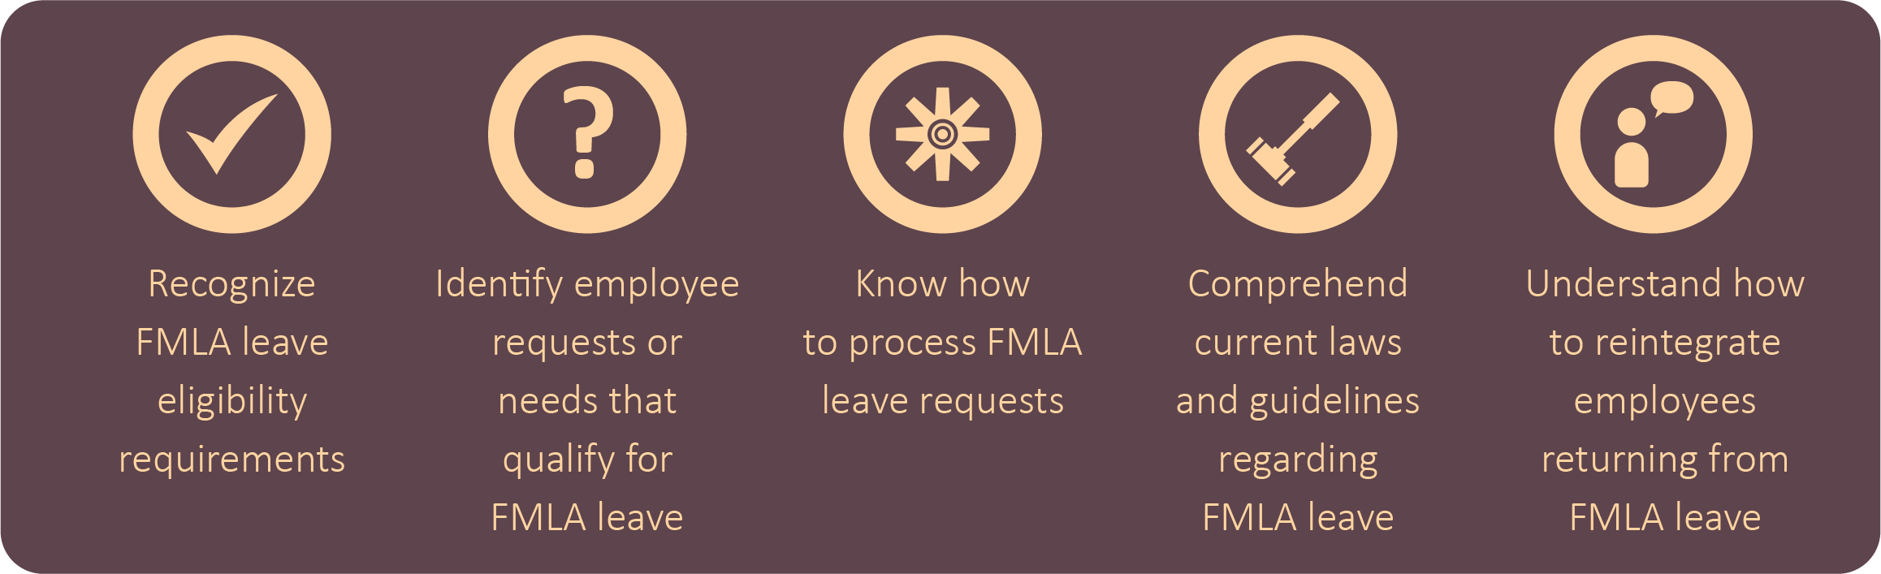
Employers can train managers to:
Managers are often in the best position to identify when leave requests may be covered by the FMLA because they tend to know why employees are requesting time off. Therefore, ensuring managers are properly trained can drastically improve an organization’s compliance efforts.
An organization can make sure its managers are sufficiently trained by establishing regular and frequent classes or workshops. At a minimum, employers can train managers on FMLA requirements at the time of hire and once per year thereafter. Employers can also provide managers with guides and resources to help improve their knowledge and understanding of the FMLA. There are many resources and training services employers can use to assist them in their training efforts, including those found on the DOL’s website.

Automated Tracking Systems or Software
Using technology to internally manage FMLA leave is becoming more common. There are many tools and services available to assist employers in complying with FMLA requirements and managing employees’ leave. For example, many employers use automated tracking systems or software, such as a case management system, to help them recognize when an employee needs FMLA leave, determine their eligibility for FMLA leave and track the employee’s leave. Technology can reduce an organization’s administrative burden, helping to ensure compliance and uncover hidden trends and data. According to the Disability Management Employer Coalition (DMEC), the use of technology to internally manage FMLA leave increases with employer size. Still, more than half of employers with less than 1,000 employees rely on manual methods for managing leave while larger companies are more likely to use home-grown, purchased or leased systems. Some employers outsource their software solutions to vendors.
Relying on technology or vendors may aid employers in complying with FMLA requirements and managing employee leave, but they do not replace manager training. Properly trained managers are often an organization’s first line of defense against FMLA violations.

Vendor Outsourcing
Third-party vendors can help organizations manage employee leave. In addition to reducing an organization’s administrative burden, vendors can improve an organization’s ability to stay informed of changing regulations and requirements. As FMLA compliance is costly and laborious, vendors may be able provide better efficiency and improved compliance than employers could do on their own. Consequently, many employers who are financially able to do so outsource their FMLA leave management to outside vendors.
Most large employers outsource their FMLA leave management. Many of these employers bundle their leave management outsourcing with other services—such as employee compensation, group health, employee assistance and wellness programs—with the same vendor. Even if employers rely on vendors, employers are ultimately responsible for complying with the FMLA. Employers need to ensure their vendors rely on and receive guidance from the best sources, such as the DOL and employment attorneys.

Leveraging Technology
Tracking and managing employee leave is an ongoing administrative challenge for employers. However, technology, such as software-based solutions, can provide employers with an effective and efficient way to manage employee leave, improve employer and employee coordination of benefits usage, reduce FMLA operational costs and enhance an employee’s leave experience. Technology is becoming a critical component for managing and facilitating FMLA leave for many organizations.
One of the most common FMLA challenges for employers is tracking employee leave eligibility. This has only become more challenging as telecommuting and flexible work arrangements have become more common. Technology can allow employers to track irregular employee schedules and ensure FMLA leave thresholds are met when employees request leave, improving FMLA administration efficiency for employers.
The use of technology tends to increase with employer size, according to DMEC’s 2020 Employer Leave Management Survey.
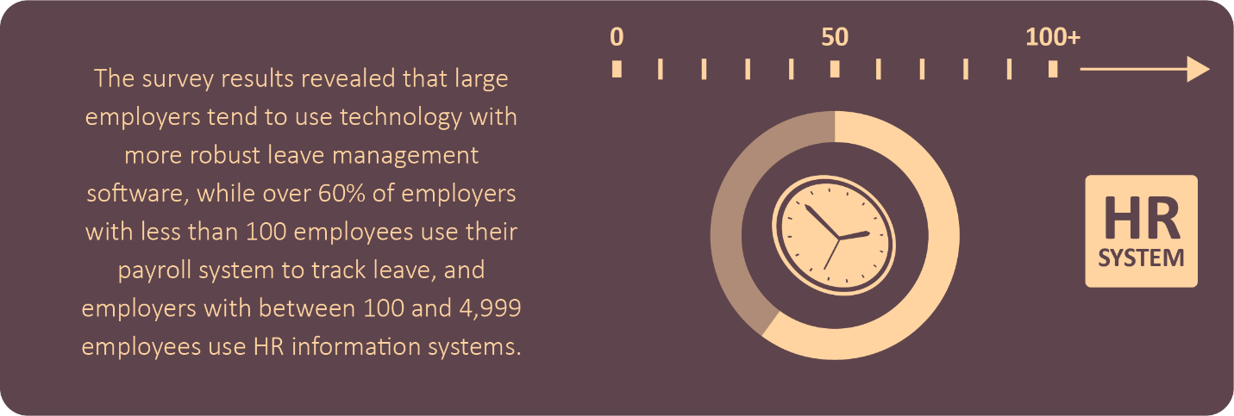
FMLA administration also is becoming more complicated as more states adopt their own family and medical leave laws. Rule-based technology systems allow employers to efficiently comply with federal and state leave requirements. Additionally, self-service technology platforms allow FMLA leave administration to be more interactive, decreasing an organization’s administrative burden. For example, mobile and desktop applications permit employees to log their time, making it easier for employers to track employee FMLA leave eligibility and usage.

FMLA Leave Abuse
Since the FMLA may be used intermittently, it can be difficult to accurately track how an employee’s 12 weeks of leave are being used. For instance, an employee may use some FMLA leave for chemotherapy appointments or prenatal doctor visits, stretching their allotted time over several months. If employers are not careful, an employee using intermittent FMLA leave might abuse their allotted time. For example, an employee may mislead their employer about why they’re taking time off from work or fail to provide sufficient FMLA documentation.
FMLA leave abuse is inherently difficult to identify, but it most commonly occurs when leave is used intermittently. Given the sensitive nature of FMLA leave abuse, it’s important for employers to establish a system for enforcing their FMLA leave policies, including methods for curbing potential abuse. Establishing deliberate policies that include specific requirements, such as call-in procedures and clear penalties for violations. Consistent enforcement is also a key consideration.
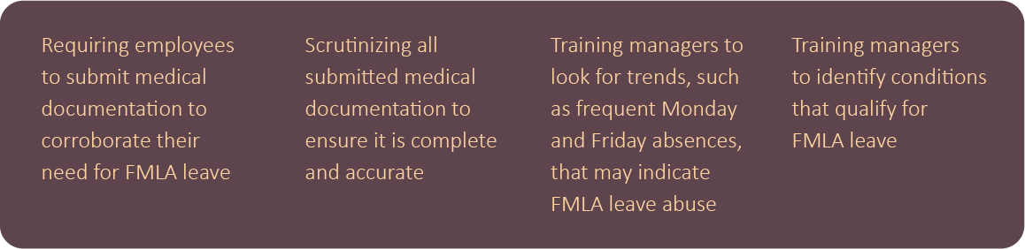
Some employer strategies for curbing FMLA leave abuse include:
FMLA leave abuse is a difficult subject for employers. They need to ensure the actions they take to curb abuse do not trigger costly settlements or judgments. Employers should consult with legal counsel regarding FMLA and other applicable leave policies before acting on suspected FMLA leave abuse.

Employee Mental Health
Mental health is becoming a growing concern in the workplace. Over the past few years, in part due to the COVID-19 pandemic, many employees have experienced mental health issues, such as burnout, depression, anxiety and substance abuse. Eligible employees may take FMLA leave to address mental health conditions. Employers can support employees struggling with mental health conditions by recognizing situations where an employee’s behavior creates difficulties or concerns at work. Employers can train managers to recognize when an employee may need FMLA leave for mental health issues.
Under the FMLA, a mental health condition is considered a serious health condition if it requires inpatient care or continuing treatment by a health care provider. In some cases, an employer may be obligated to treat an employee’s behavior as a request for FMLA leave. Employers may require an employee to submit a certification from a health care provider to support their need for FMLA leave. While the certification does not require a diagnosis, the information provided must be sufficient enough to support the need for leave.
The FMLA permits eligible employees to take leave to provide care for a spouse, child or parent who is unable to work or perform other regular daily activities because of a mental health condition. Providing psychological comfort and reassurance that would be beneficial to a family member with a serious health condition who is receiving inpatient care or home care is covered by the FMLA.
Employers are required to keep employee medical records confidential and maintain them separately from regular personnel files. Employers may inform supervisors and managers of an employee’s need for leave or if an employee requires work restrictions or accommodations.

Telemedicine
The DOL has stated that it will consider telemedicine visits as “in-person” visits for purposes of establishing a serious health condition under the FMLA if certain criteria are met. To qualify, the telemedicine visit must:
- Include an examination, evaluation or treatment by a health care provider
- Be permitted or accepted by state licensing authorities
- Be generally performed by video conference
Communication methods, such as a telephone call, letter, email or text message, are not sufficient to qualify the requirements of an “in-person” visit. Employers should evaluate their current FMLA policies to ensure qualifying telemedicine visits are included for establishing a serious health condition.

Remote Workers
In the wake of the COVID-19 pandemic, more employers are permitting their employees to work remotely. Employers need to understand FMLA-eligibility requirements for remote workers. To qualify for FMLA protections, an eligible employee must work at a location where the employer has at least 50 employees within 75 miles. An employee’s personal residence is not a worksite for employees who telecommute. According to guidance from the DOL, a worksite is the office to which an employee reports or from where they receive assignments. Therefore, employers need to determine the worksite location to which the employee reports or from which their assignments are made and whether that worksite has at least 50 employees, including all remote workers assigned or reporting to that worksite. After doing so, they can determine whether FMLA protections apply to any of their remote employees.
To manage FMLA leave for remote workers, it’s important for employers to understand the workflow of the organization and to keep track of the correct worksite for all employees, including remote employees. Organizations can invest in technology solutions to help track workflow and employee worksites. Employers may also need to consider an employee’s eligibility for benefits under state family and medical leave laws.

Summary
FMLA compliance is often an ongoing challenge for many employers. Ensuring compliance requires employers to prioritize implementing processes and procedures, such as software solutions and management training, and reevaluating them often. While best practices will vary depending on the size of the employer and industry, understanding common FMLA-related challenges and current trends can help organizations implement strategies and solutions that best meet their needs.

Common Employer Questions
At first glance, the FMLA can seem straightforward. Yet, many employers struggle with compliance. Employers must often respond quickly to address complex situations. This can be especially challenging when FMLA guidance is limited or solutions are not readily apparent.
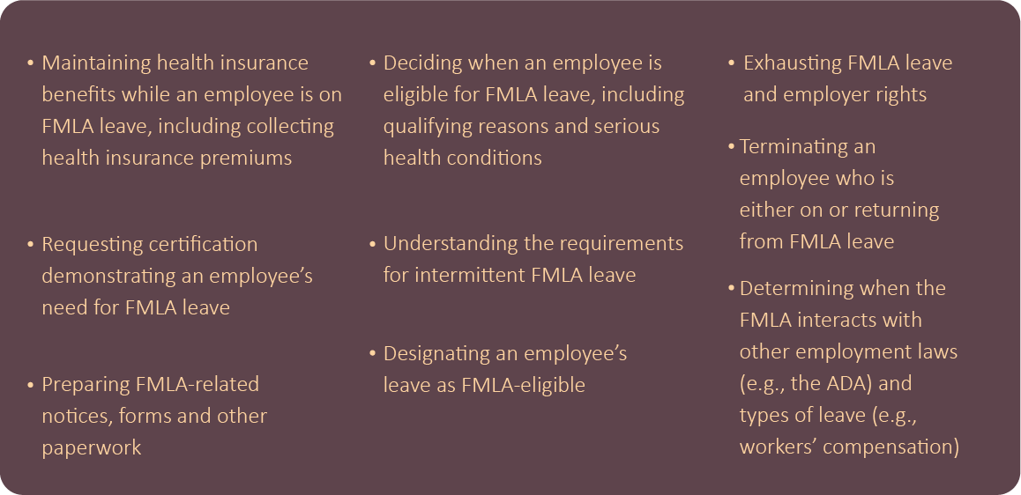
Some of the most common FMLA-related topics employers have questions about include the following:
This section addresses common questions employers have regarding the FMLA and provides general answers. Due to the complex nature of the FMLA, employers are encouraged to discuss any specific FMLA-related questions with an employment attorney.
Must an employer offer FMLA leave to an employee if they work remotely from home and the employer does not have a worksite within a 75-mile radius of that employee’s home?
An employee working from home may be eligible for FMLA leave if their employer is a covered employer—meaning it employs 50 or more employees. According to the FMLA’s regulations, an employee’s personal residence is not considered a worksite in the case of employees who work at home, as under the concept of telecommuting. Instead, their workplace is the office to which they report and from which assignments are made. So, if 50 employees are employed within 75 miles from the employee’s worksite, the employee meets the requirements for the test, regardless of where the employee is currently performing their duties.
If an employee does not meet the eligibility requirements, an employer may not designate the employee’s leave as FMLA leave even if the leave would otherwise qualify for FMLA protection. Even if an employee is not eligible for FMLA leave, an employer may grant the employee leave under the employer’s leave policy. Employers are not prevented from establishing leave policies that are similar to, or more generous than, the FMLA’s minimal requirements.

Can an employer request that an employee who is on intermittent FMLA leave for treatment provide proof of each doctor’s visit?
Under certain circumstances, an employer may request that an employee “recertify” their serious health condition or that of their family member within the same leave year. Generally, an employer may request that an employee provide recertification no more often than every 30 days and only when the employee is actually absent or has requested to be absent from work.
In some instances, an employer must wait longer than 30 days to request recertification. If the initial certification indicates that the minimum duration of the serious health condition will be more than 30 days, an employer must generally wait until that minimum duration expires before requesting recertification.
In all cases, an employer may request recertification every six months in connection with an employee’s absence. If the initial medical certification indicates that the employee will need intermittent or reduced-schedule leave for longer than six months, including cases where the serious health condition has no anticipated end, the employer may request a recertification every six months but only in connection with an absence by the employee.
An employer may request recertification in connection with an employee absence in less than 30 days only in the following circumstances:
- The employee requests an extension of leave.
- The circumstances described by the previous certification have changed significantly.
- The employer receives information that casts doubt on the employee’s stated reason for the absence or the continuing validity of the existing medical certification.
Can an employer terminate an employee who took FMLA leave to care for a family member, but the leave is now expired? Or can the employer only terminate the employee’s group health plan benefits?
Terminating an employee is a business decision, and no termination is without risk. An employer needs to decide whether it can provide the employee who has exhausted their FMLA leave with additional leave to care for their family member. How the employer decides to handle this situation could set a precedent for future situations. Consequently, the employer may want to determine if there are any similar past situations it can reference.
The Equal Employment Opportunity Commission’s (EEOC) guidance provides that employers must consider leave from work, including leave beyond any FMLA leave entitlement, as a reasonable accommodation under the ADA. However, the ADA does not require an employer to provide an employee with accommodations based on the employee’s relationship to someone with a disability. An employer is only obligated to consider reasonable accommodations for the employee’s disability. Only qualified applicants and employees with disabilities are entitled to reasonable accommodations under the ADA. For example, the ADA would not require an employer to modify its leave policy for an employee who needs time off to care for a family member with a disability. But an employer must avoid treating an employee differently than other employees because of their association with a person with a disability.
If an employee’s group health plan benefits are terminated due to the employee’s reduction in hours due to leave beyond their FMLA leave entitlement, this is a qualifying event under COBRA. Employers are encouraged to review the DOL’s guide for information on when a COBRA-qualifying event may occur in connection with FMLA leave. Generally, a COBRA-qualifying event in connection with FMLA leave arises if an employee is covered on the day before the first day of FMLA leave—or becomes covered during the FMLA leave—under the employer’s group health plan, and the employee does not return to work at the end of the FMLA leave. The employee would, in the absence of COBRA-continuing coverage, lose coverage under their employer’s group health plan. The COBRA-qualifying event occurs on the last day of the employee’s FMLA leave.
However, employers should review the terms of their specific plan or policy to determine if additional leave provided beyond the FMLA may cause a reduction in hours and loss of health coverage. If the terms of the plan or policy provide for termination of coverage upon the exhaustion of an employee’s FMLA leave, COBRA-continuation coverage may need to be offered. A reduction in an employee’s hours that causes a loss of eligibility under the policy or plan’s terms is a COBRA-qualifying event. For more information, employers are encouraged to refer to the DOL’s employer’s guide to the FMLA.
If an employee exhausts their 12 weeks of FMLA leave but provides their employer with a doctor’s note requesting additional leave, what obligations does the employer have?
If an employee exhausts their FMLA leave, an employer has an obligation under the ADA to consider whether providing additional leave beyond the employee’s FMLA leave entitlement is a reasonable accommodation. For more information regarding this topic, employers are encouraged to review the EEOC’s guidance on this topic, which includes specific examples that employers may find helpful. While the ADA is not a leave law, it requires employers to consider additional leave beyond the FMLA as a reasonable accommodation.
How much leave is considered “reasonable” is not definitive. However, whether any amount of leave is “reasonable” must be based on the specific facts and circumstances of the individual situation, including the impact on the employer’s operations and whether the leave will enable the employee to return to work and perform essential job functions.
Can employers with less than 50 employees offer FMLA leave to their employees?
If an employer is not a “covered employer” under the FMLA, then its employees are not eligible for or entitled to any FMLA benefits. However, employers can decide to adopt policies that are more generous than required by law and choose to provide leave in situations where it’s not legally required. Importantly, even if an employer chooses to provide leave that is not legally required, an employee on such leave may lose benefits coverage due to a reduction in hours worked and may need to be offered COBRA-continuing coverage. Additionally, unlike the FMLA, an employee’s personal leave of absence generally does not provide job protection or reinstatement rights unless otherwise stated in the employer’s policies. If employers choose to provide leave beyond what’s legally required, they should consider implementing a formal policy and ensure it’s administered on a consistent basis. Employers can choose the parameters of their personal leave of absence policy, such as the length of time permitted, whether leave is paid or unpaid, and requirements and a timeline for providing medical certification. Employers should consider working with an attorney when drafting and implementing such a policy to ensure legal compliance. For a sample non-FMLA leave policy, employers are encouraged to review Zywave’s policy document.
If an employer discovers issues with an employee’s job performance while that employee is on FMLA leave, can the employer terminate the employee when the employee returns to work after their leave expires?
An employee’s leave status, request for medical leave or disclosure of a health issue does not prevent an employer from terminating that employee based on performance or another lawful reason. However, the employer must be able to demonstrate that the terminated employee would have been discharged even if the employee had not taken or requested FMLA leave. In other words, an employer must demonstrate a legitimate, nondiscriminatory business reason for terminating the employee that’s unrelated to their requested and taken FMLA leave. If an employee feels they were subjected to retaliation or discrimination for requesting or taking FMLA leave and pursues legal action against the employer, the courts put the burden on the employer to prove that the employee would have been disciplined or terminated regardless of the FMLA leave request or status.
As with any termination situation, the employer will want to carefully document all records of disciplinary warnings or unsatisfactory performance to prove, if necessary, its reasons for terminating the employee were job-related, consistent with business necessity and not related to the employee’s health condition or request for leave. Complete and accurate documentation, including business-related reasons for terminating employment, offers evidence of what occurred, promotes consistency and objectivity, and is necessary for employers to support their decisions regarding employee discipline and termination.
Terminating an employee is a very sensitive matter that requires careful communication and documentation to avoid potential lawsuits or other future problems. Employers should consult an attorney for further guidance.

Summary
For more almost 30 years, the FMLA has allowed employees to take unpaid, job-protected leave to care for their own serious health condition or that of a family member. While the FMLA’s protections and guarantees appear straightforward, employers can regularly review their policies and procedures to evaluate how well they’re meeting FMLA requirements and correct any administrative deficiencies. Strategies for implementing a successful FMLA process will likely vary depending on the size of the employer and the location of their employees, but an effective process can help organizations improve their FMLA compliance, reduce organizational inefficiencies and better support employees. Prioritizing FMLA compliance and administration can aid organizations in saving time, reducing waste and avoiding costly violations.
While this HR Toolkit provides an overview of the FMLA’s provisions, in many situations, employees may be entitled to additional protections under other federal employment laws, state family and medical leave laws and collective bargaining agreements. Accordingly, employers are encouraged to discuss any specific FMLA-related questions with an employment attorney.
Contact George Belcher Evans & Wilmer for more information about the FMLA process, compliance and best practices.

Appendix
FMLA requirements are complex and can be difficult and time-consuming. This section takes away some of that burden by offering valuable resources that you can print or email and use for your organization. This appendix features an infographic, compliance checklist, sample policy and forms, employee communications and FMLA guidelines. Please review these resources when implementing FMLA policies or assessing your organization’s FMLA process. The information included in this section may require some customization, and it should only be used as a framework. Due to the complex nature of FMLA compliance, organizations are encouraged to seek legal counsel to discuss and address specific issues and concerns.
The resources included in this appendix are just a small sampling of the materials that are available to employers. By contacting George Belcher Evans & Wilmer, employers may have access to an entire library of FMLA-related materials. Please speak with George Belcher Evans & Wilmer if you have any questions about these materials or any other content in this HR Toolkit.

Printing Help
There are many printable resources in this appendix. Please follow the instructions below if you need help printing individual pages.
- Choose the “Print” option from the “File” menu.
- Under the “Settings” option, click on the arrow next to “Print All Pages” to access the drop-down menu. Select “Custom Print” and enter the page number range you would like to print, or enter the page number range you would like to print in the “Pages” box.
- Click “Print.” For more information, please visit the Microsoft Word printing support page.

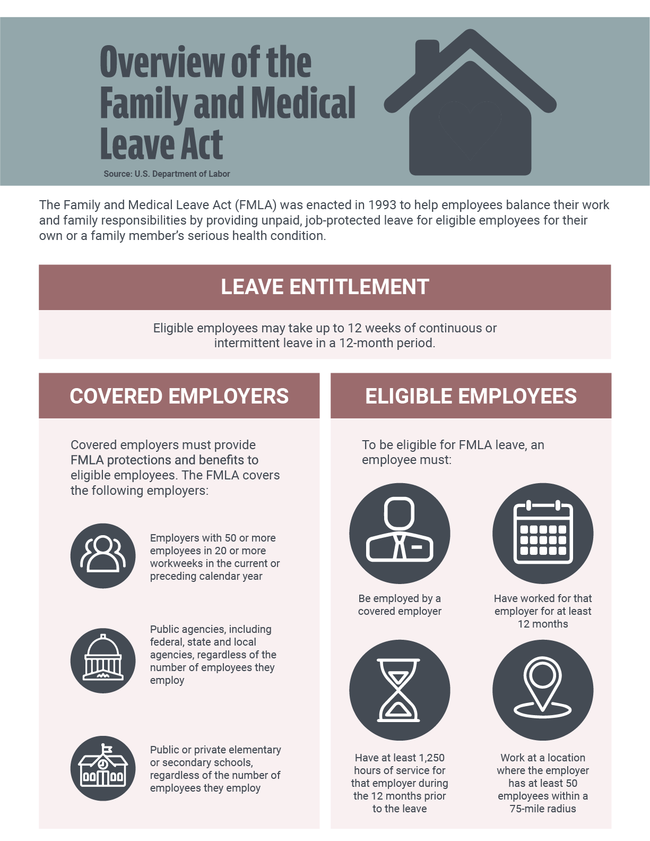

Overview of the Family and Medical Leave Act Infographic

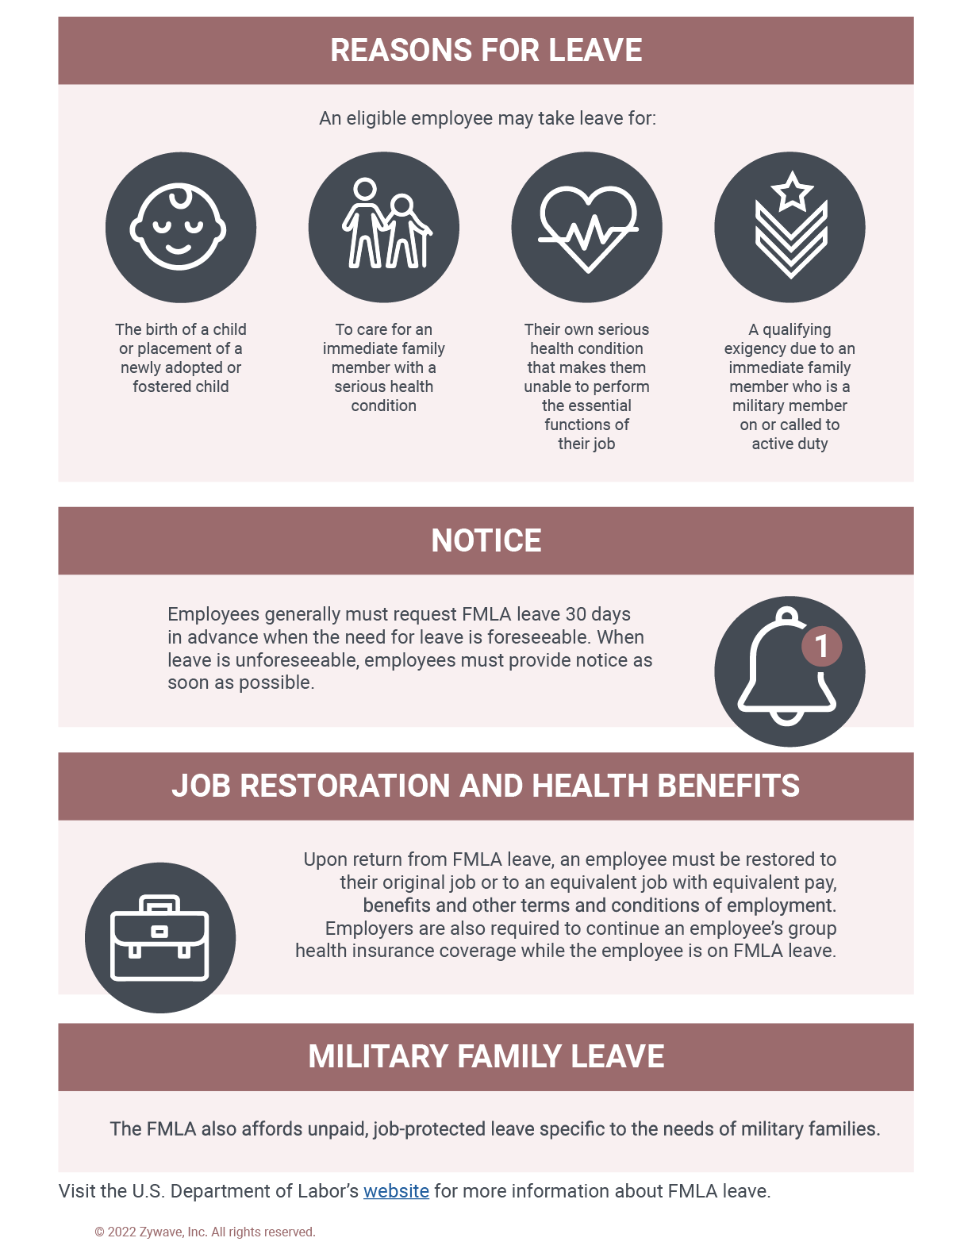

FMLA Glossary for Small Businesses

FMLA Glossary for Small Businesses

Provided by: George Belcher Evans & Wilmer

The Family and Medical Leave Act (FMLA) allows eligible employees of covered employers to take unpaid, job-protected leave for specified family and medical reasons. In order to better support employees and avoid potential unlawful practices, it’s important for employers to understand the various FMLA requirements and how they apply in the context of their small businesses.
This glossary contains definitions from the U.S. Department of Labor (DOL) of some common FMLA terms, including “serious health condition,” “physical” or “mental disability,” and “eligible employee.”
Employers can use this resource to better understanding of common terms used by the FMLA and to help ensure their small businesses have proper employment practices in place.

ACT—The Family and Medical Leave Act of 1993.
ADA—The Americans with Disabilities Act of 1990.
ADMINISTRATOR—The administrator of the Wage and Hour Division (WHD) of the DOL and includes any official of the WHD authorized to perform any of the functions of the administrator.
CHILD—A biological, adopted or foster child, a stepchild, a legal ward or a child of a person standing in loco parentis, who is either under age 18 or age 18 or older and “incapable of self-care because of a mental or physical disability” at the time that FMLA leave is to commence.
COBRA—The continuation coverage requirements of Title X of the Consolidation Omnibus Reconciliation Act of 1986.
COMMERCE—Any activity, business or industry in commerce or in which a labor dispute would hinder or obstruct commerce of the free flow of commerce and includes “commerce” and any “industry affecting commerce” as defined by the Labor Management Relations Act of 1974.
CONTINUING TREATMENT BY A HEALTH CARE PROVIDER—This means any one of the following:
  - Incapacity and treatment—A period of incapacity of more than three consecutive, full calendar days and any subsequent treatment or period of incapacity relating to the same condition that also involves one of the following:
    - Treatment two or more times within 30 days of the first day of incapacity, unless extenuating circumstances exist, by a health care provider, a nurse under the direct supervision of a health care provider, or a provider of health care services (e.g., physical therapist) under orders of or on referral by a health care provider.
    - Treatment by a health care provider on at least one occasion, which results in a regimen of continuing treatment under the supervision of the health care provider. Whether additional treatment visits or a regimen of continuing treatment is necessary within the 30-day period shall be determined by the health care provider.
  - Pregnancy or prenatal care—Any period of incapacity due to pregnancy or for prenatal care.
  - Chronic conditions—Any period of incapacity or treatment for incapacity due to a chronic serious health condition. A chronic serious health condition is one that:
    - Requires periodic visits (defined as at least twice a year) for treatment by a health care provider or a nurse under the direct supervision of a health care provider
    - Continues over an extended period of time, including recurring episodes of a single underlying condition
    - May cause episodic rather than a continuing period of incapacity (e.g., asthma, diabetes and epilepsy)
  - Permanent or long-term conditions—A period of incapacity that is permanent or long-term due to a condition for which treatment may not be effective. The employee or family member must be under the continuing supervision of but need not be receiving active treatment by a health care provider. Examples include Alzheimer’s disease, a severe stroke or the terminal stages of a disease.
  - Conditions requiring multiple treatments—Any period of absence to receive multiple treatments (including any period of recovery therefrom) by a health care provider or a provider of health care services under orders of or on referral by a health care provider for:
    - Restorative surgery after an accident or other injury
    - A condition that would likely result in a period of incapacity of more than three consecutive full calendar days in the absence of medical intervention or treatment, such as cancer, severe arthritis and kidney disease
  - Absences attributable to incapacity due to pregnancy, prenatal care or chronic conditions qualify for FMLA leave even though the employee or the covered family member does not receive treatment from a health care provider during the absence and even if the absence does not last more than three consecutive full calendar days.
COVERED ACTIVE DUTY OR CALL TO COVERED ACTIVE DUTY STATUS—In the case of a member of the regular U.S. armed forces, this means duty during the deployment of the member with the U.S. armed forces to a foreign country. In the case of a member of the U.S. Army Reserve, duty during the deployment of the member with the U.S. armed forces to a foreign country under a federal call or order to activity duty in support of a contingency operation under U.S. Code Title 10.
COVERED SERVICE MEMBER—A current member of the U.S. armed forces, including a member of the National Guard or Army Reserve, who is undergoing medical treatment, recuperation or therapy, is otherwise in outpatient status or on temporary disability retired list for a serious injury or illness. It can also mean a covered veteran who is undergoing medical treatment, recuperation or therapy for a serious injury or illness.
COVERED VETERAN—An individual who was a member of the U.S. armed forces, including a member of the National Guard or Army Reserves, and was discharged or released under conditions other than dishonorable at any time during a five-year period prior to the first date the eligible employee takes FMLA leave to care for the covered veteran.
DAUGHTER—See “Child.”
ELIGIBLE EMPLOYEE—An employee who has been employed for a total of at least 12 months by the employer on the date on which any FMLA leave is to commence; has met the hours of service requirement by having been employed for at least 1,250 hours of service with the employer during the previous 12-month period or, for an airline flight crew employee, in the previous 12 months has worked or been paid for not less than 60% of the applicable total monthly guarantee and has worked or been paid for not less than 504 hours, not counting personal commute time or vacation, medical or sick leave; and who is employed in any U.S. state, the District of Columbia or any territories or possession of the United States. This does not include any federal officer or employee; any employee who is employed at a worksite at which the employer employs fewer than 50 employees if the total number of employees employed by that employer within 75 miles of that worksite is also fewer than 50; or any employee employed in any country other than the United States or any territory or possession of the United States. For purposes of determining if an individual is an eligible employee, an employer does not need to consider any period of previous employment that occurred more than seven years before the date of the most recent hiring of the employee unless the break in service is occasioned by the fulfillment of the employee’s covered service obligations under the Uniformed Services Employment and Reemployment Rights Act or a written agreement, including a collective bargaining agreement.
EMPLOY—To suffer or permit to work.
EMPLOYEE—Any individual employed by an employer, including the U.S. government, U.S. Postal Service or Postal Regulation Commission, and any U.S. state or political subdivision of a state. Under the FMLA, “employee” has the same meaning as defined in Section 3(e) of the FLSA.
EMPLOYER—Any person engaged in commerce or in an industry or activity affecting commerce who employs 50 or more employees for each working day during each of 20 or more calendar workweeks in the current or preceding calendar year. This also includes any person who directly or indirectly acts in the interest of an employer, any successor in interest of an employer and any public agency.
EMPLOYMENT BENEFITS—All benefits provided or made available to employees by an employer, including group life insurance, health insurance, disability insurance, sick leave, annual leave, educational benefits and pensions, regardless of whether such benefits are provided by a practice or written policy of an employer or through an employee benefit plan. This does not include nonemployment-related obligations paid by employees through voluntary deductions, such as supplemental insurance coverage.
EXTENUATING CIRCUMSTANCES—Circumstances beyond the employee’s control that prevent the follow-up visit from occurring as planned by the health care provider. Whether a given set of circumstances are extenuating depends on the facts.
FLSA—The Fair Labor Standards Act.
GROUP HEALTH PLAN—Any plan of, or contributed to by, an employer (including a self-insured plan) to provide health care (directly or otherwise) to the employer’s employees, former employees or the families of such employees or former employees. For purposes of the FMLA, the term “group health plan” shall not include an insurance program providing health coverage under which employees purchase individual policies from insurers provided that no contributions are made by the employer; participation in the program is voluntary; the employer’s sole functions with respect to the program are to permit the insurer to publicize the program to employees, collect premiums through payroll deductions and remit them to the insurer; the employer receives no consideration in the form of cash or otherwise in connection with the program; and the premium charged does not increase in the event the employment relationship is terminated.
HEALTH CARE PROVIDER—A doctor of medicine or osteopathy who is authorized to practice medicine or surgery (as appropriate) by the state in which the doctor practices or any other person determined by the U.S. secretary of labor to be capable of providing health care services. Others “capable of providing health care services” only include the following:
  - Podiatrists, dentists, clinical psychologists, optometrists and chiropractors (limited to treatment consisting of manual manipulation of the spine to correct a subluxation as demonstrated by X-ray to exist) authorized to practice in the state and performing within the scope of their practice as defined under state law
  - Nurse practitioners, nurse midwives, clinical social workers and physician assistants who are authorized to practice under state law and who are performing within the scope of their practice as defined under state law
  - Christian Science practitioners listed with the First Church of Christ, Scientist in Boston, Massachusetts
  - Any health care provider from whom an employer or the employer’s group health plan’s benefits manager will accept certification of the existence of a serious health condition to substantiate a claim for benefits
  - Health care provider listed above who practices in a country other than the United States, who is authorized to practice in accordance with the law of that country and is performing within the scope of his or her practice as defined under such law
“Authorized to practice in the state” means that a provider must be authorized to diagnose and treat physical or mental health conditions.
INCAPABLE OF SELF-CARE—An individual requires active assistance or supervision to provide daily self-care in several of the “activities of daily living” or “instrumental activities of daily living.” Activities of daily living include adaptive activities, such as caring appropriately for one’s grooming and hygiene, bathing, dressing and eating. Instrumental activities of daily living include cooking, cleaning, shopping, taking public transportation, paying bills, maintaining a residence, using telephones and directories and using a post office.
INTERMITTENT LEAVE—Leave taken in separate periods of time due to a single illness or injury rather than for one continuous period of time, and may include leave of periods from an hour or more to several weeks. Examples of intermittent leave would include leave taken on an occasional basis for medical appointments or leave taken several days at a time spread over a period of six months, such as for chemotherapy.
KEY EMPLOYEE—A salaried FMLA-eligible employee who is among the highest-paid 10% of all the employees employed by the employer within 75 miles of the employee’s worksite.
IN LOCO PARENTIS—Persons with day-to-day responsibilities to care for or financially support a child. It’s a relationship in which a person has put themselves in the situation of a parent by assuming and discharging the obligations of a parent to a child, and it exists when an individual intends to take on the role of a parent.
MILITARY CAREGIVER LEAVE—Leave taken to care for a covered service member with a serious injury or illness under the FMLA.
NEXT OF KIN OF A COVERED SERVICE MEMBER—The nearest blood relative other than the covered service member’s spouse, parent, son or daughter in the following order of priority: blood relatives who have been granted legal custody of the covered service member by court decree or statutory provisions; brothers and sisters; grandparents; aunts and uncles; and first cousins, unless the covered service member has specifically designated in writing another blood relative as his or her nearest blood relative for purposes of military caregiver leave under the FMLA. When no such designation is made and there are multiple family members with the same level of relationship to the covered service member, all such family members shall be considered the covered service member’s next of kin and may take FMLA leave to provide care to the covered service member, either consecutively or simultaneously. When such designation has been made, the designated individual shall be deemed to be the covered service member’s only next of kin.
OUTPATIENT STATUS—With respect to a covered service member who is a current member of the U.S. armed forces; the status of a member of the armed forces assigned to either a military medical treatment facility as an outpatient; or a unit established for the purpose of providing command and control of members of the U.S. armed forces receiving medical care as outpatients.
PARENT—A biological, adoptive, step- or foster father or mother, or any other individual who stood in loco parentis to the employee when the employee was a son or daughter, as defined below. This term does not include parents “in law.”
PERSON—An individual, partnership, association, corporation, business trust, public agency, legal representative or any organized group of persons.
PHYSICAL OR MENTAL DISABILITY—A physical or mental impairment that substantially limits one or more of the major life activities of an individual, as defined by the ADA.
PUBLIC AGENCY—The government of the United States; the government of a state or political subdivision thereof; any agency of the United States, including the U.S. Postal Service and Postal Regulatory Commission, a state or a political subdivision of a state, or any interstate governmental agency.
REDUCE LEAVE SCHEDULE—A leave schedule that reduces an employee’s usual number of hours per workweek or hours per workday.
SERIOUS HEALTH CONDITION—An illness, injury, impairment or physical or mental condition that involves inpatient care or continuing treatment by a health care provider. Conditions for which cosmetic treatments are administered, such as most treatments for acne or plastic surgery, are not “serious health conditions” unless inpatient hospital care is required or unless complications develop. Restorative dental or plastic surgery after an injury or removal of cancerous growths are serious health conditions provided all the other conditions of the FMLA are met. Mental illness or allergies may be serious health conditions, but only if all the conditions of a serious health condition are met.
SERIOUS INJURY OR ILLNESS—In the case of a current member of the U.S. armed forces, including a member of the National Guard or U.S. Army Reserve, an injury or illness that was incurred by the covered service member in the line of duty on active duty in the U.S. armed forces or that existed before the beginning of the member’s active duty and was aggravated by service in the line of duty on active duty in the armed forces and that may render the service member medically unfit to perform the duties of the member’s office, grade, rank or rating. In the case of a covered veteran, an injury or illness was incurred by the member in the line of duty on active duty in the U.S. armed forces or existed before the beginning of the member’s active duty and was aggravated by service in the line of duty on active duty in the armed forces and manifested itself before or after the member became a veteran and is one of the following:
  - A continuation of a serious injury or illness that was incurred or aggravated when the covered veteran was a member of the U.S. armed forces and rendered the service member unable to perform the duties of the service member’s office, grade, rank or rating.
  - A physical or mental condition for which the covered veteran has received a U.S. Department of Veterans Affairs Service-Related Disability Rating (VASRD) of 50% or greater and such VASRD rating is based, in whole or in part, on the condition precipitating the need for military caregiver leave.
  - A physical or mental condition that substantially impairs the covered veteran’s ability to secure or follow a substantially gainful occupation by reason of disability or disabilities related to military service or would do so absent treatment.
  - An injury, including a psychological injury, that is the basis on which the covered veteran has been enrolled in the U.S. Department of Veterans Affairs Program of Comprehensive Assistance for Family Caregivers.
SON—See “Child.”
SPOUSE—A husband or wife as defined or recognized in the state where the individual was married. This definition includes individuals in a same-sex marriage or common-law marriage. Spouse also includes a husband or wife in a marriage that was validly entered into outside of the United States if the marriage could have been entered into in at least one state.
STATE—Any state of the United States, the District of Columbia, or any territory or possession of the United States.
TREATMENT BY A HEALTH CARE PROVIDER— An in-person visit to a health care provider. The first in-person treatment visit must take place within seven days of the first day of incapacity.

Source: U.S. Department of Labor

FMLA Guidelines
PROVISION | REQUIREMENTS
Covered Employers | Employers subject to the FMLA include:  - Private-sector employers with 50 or more employees in at least 20 weeks of the current or preceding year;  - Public agencies, including state, local and federal employers; and  - Local education agencies, including elementary and secondary schools (public and private).
Eligible Employees | To be eligible for FMLA leave, an employee must:  - Have worked for the covered employer for at least 12 months (which need not be consecutive);  - Have at least 1,250 hours of service for the employer during the 12-month period immediately before the leave; and  - Work at a location within 75 miles of which the employer has 50 or more employees.
Type of Leave | Eligible employees may take unpaid leave under the FMLA for the following reasons:  - The birth of the employee’s newborn child;  - The placement of a child with the employee for adoption or foster care;  - A serious health condition that makes the employee unable to perform the functions of his or her job;  - To care for the employee’s spouse, child or parent who has a serious health condition;  - Any qualifying exigency arising out of the fact that the employee’s spouse, child or parent is a military member on covered active duty (or call to covered active duty status); or  - To care for a spouse, child, parent or next of kin who is a covered service member with a serious injury or illness.
Leave Amount | In general, employees may take up to 12 weeks of FMLA leave during a 12-month period.  Employees may take up to 26 weeks of leave during a single 12-month period to care for a spouse, child, parent or next of kin who is a covered service member with a serious injury or illness.  Spouses who work for the same employer are limited to a combined total of 12 weeks of leave to care for a parent with a serious health condition or following the birth, adoption or placement of a child. Spouses who work for the same employer are limited to a combined total of 26 weeks of leave to care for a covered service member with a serious injury or illness if each spouse is a parent, spouse, son or daughter, or next of kin of the servicemember.
Serious Health Condition | An illness, injury, impairment, or physical or mental condition that involves inpatient care or continuing treatment by a health care provider. Serious health conditions may include:  - An overnight stay in a hospital, hospice or residential medical care facility, including any period of incapacity or subsequent treatment in connection with the overnight stay;  - A period of incapacity of more than three consecutive full calendar days that involves a certain level of treatment from a health care provider;  - A period of incapacity due to (or treatment for) a chronic serious health condition;  - A period of incapacity which is permanent or long-term due to a condition for which treatment may be ineffective;  - Absences to receive multiple treatments (including recovery periods) for a restorative surgery or for a condition that if left untreated likely would result in incapacity of more than three days; or  - Any incapacity related to pregnancy or for prenatal care.  Incapacity means inability to work, or inability to attend school, or perform other regular daily activities due to the serious health condition.
Covered Service Member | A “covered service member” is:  - A current member of the Armed Forces, including a member of the National Guard or Reserves, who is undergoing medical treatment, recuperation or therapy, is otherwise in outpatient status or is otherwise on the temporary disability retired list for a serious injury or illness; or  - A veteran who is undergoing medical treatment, recuperation or therapy for a serious injury or illness and who was a member of the Armed Forces, including a member of the National Guard or Reserves, and was discharged or released under conditions other than dishonorable at any time during the five-year period prior to the first date the eligible employee takes FMLA leave to care for the covered veteran.
Serious Injury or Illness | In the case of a member of the Armed Forces, including a member of the National Guard or Reserves, a “serious injury or illness” is an injury or illness incurred by the member in the line of duty on active duty in the Armed Forces (or which existed before the beginning of active duty and was aggravated by service in the line of duty on active duty) that may render the member medically unfit to perform the duties of the member’s office, grade, rank or rating.  For a veteran of the Armed Forces, including a veteran of the National Guard or Reserves, a “serious injury or illness” is an injury or illness incurred by the member in the line of duty on active duty in the Armed Forces (or which existed before the beginning of active duty and was aggravated by service in the line of duty on active duty) and that manifested itself either before or after the member became a veteran and is:  - A continuation of a serious injury or illness that was incurred or aggravated when the covered veteran was a member of the Armed Forces and rendered the member unable to perform the duties of his or her office, grade, rank or rating;  - A physical or mental condition for which the covered veteran has received a U.S. Department of Veterans Affairs Service-Related Disability Rating (VASRD) of 50 percent or greater, and the VASRD rating is based, in whole or in part, on the condition precipitating the need for military caregiver leave;  - A physical or mental condition that substantially impairs the covered veteran's ability to secure or follow a substantially gainful occupation by reason of a disability or disabilities related to military service, or would do so absent treatment; or  - An injury, including a psychological injury, on the basis of which the covered veteran has been enrolled in the Department of Veterans Affairs Program of Comprehensive Assistance for Family Caregivers.
Qualifying Exigency | Eligible employees may take FMLA leave for one or more of the following qualifying exigencies:  - Short-notice deployment (leave can be used for a period of seven days beginning on the date the military member is notified of a call to active duty);  - Military events and related activities, such as attendance at official ceremonies, informational briefings, family support or assistance programs, etc.;  - Childcare and school activities;  - Financial and legal arrangements;  - Counseling (leave can be used to attend counseling if the need arises from the active duty or call to active duty of the military member);  - Rest and recuperation (leave can be used for up to 15 calendar days, beginning on the date the military member commences each instance of rest and recuperation leave);  - Post-deployment activities, such as attendance at arrival ceremonies, reintegration briefings and events or other official ceremonies or programs for a period of 90 days following the termination of active duty status, or to address issues that arise from the death of the military member;  - Parental care (when the parent of the military member is incapable of self-care and is the member’s biological, adoptive, step or foster father or mother, or any other individual who stood in loco parentis to the military member when the member was under 18 years of age); and  - Additional activities, such as to address other events that the employer and employee agree qualify as an exigency.
Health Care Provider | The term “health care provider” includes:  - Doctors of medicine or osteopathy authorized to practice medicine or surgery;  - Podiatrists, dentists, clinical psychologists, clinical social workers, physician assistants, optometrists, chiropractors (limited to manual manipulation of spine to correct subluxation shown to exist by x-ray), nurse practitioners, and nurse-midwives, if authorized to practice under state law and consistent with the scope of their authorization;  - Christian Science practitioners listed with the First Church of Christ, Scientist in Boston, MA;  - Any provider so recognized by the employer or its group health plan's benefits manager; and  - Any health provider listed above who practices and is authorized to practice in a country other than the United States.
Intermittent Leave | Employees are entitled to take FMLA leave on an intermittent or reduced schedule basis:  - When there is a medical need for this type of leave for an employee’s own serious health condition;  - To care for a spouse, parent or child with a serious health condition; or  - To care for a covered service member with a serious injury or illness.  An employee is also entitled to use intermittent or reduced schedule leave for qualifying exigencies.  An employee is not entitled to take intermittent leave for the birth and care of a newborn child or for the placement with the employee of a child for adoption or foster care unless the employer agrees to the arrangement.
Substitution of Paid Leave | An eligible employee may choose, or an employer may require the employee to substitute, accrued paid leave for unpaid FMLA leave. Substitute means that the accrued paid leave will run concurrently with the unpaid FMLA leave. An employee’s ability to substitute accrued paid leave is determined by the terms and conditions of the employer’s normal leave policy.
Reinstatement Rights | Following FMLA leave, an employee must be restored to the same position or one equivalent to it in all benefits and other terms and conditions of employment.
Key Employee Exception to Reinstatement Rights | There is a limited exception to the FMLA’s reinstatement requirement for a salaried employee if he or she is among the highest paid 10 percent of all employees within 75 miles of the employee’s worksite, restoration would lead to grievous economic harm to the employer and other conditions are met.
Maintenance of Health Benefits During Leave | Health insurance must be continued under the same conditions as prior to leave. If applicable, arrangements must be made for employees to pay their share of health insurance premiums while on leave. In some instances, the employer may recover premiums it paid to maintain health coverage for an employee who fails to return to work from FMLA leave.
Leave Requests | An employee must give at least 30 days’ advance notice of the need to take FMLA leave when he or she knows about the need for the leave in advance and it is possible and practical to do so.  For planned medical treatment, the employee must consult with his or her employer and try to schedule the treatment at a time that minimizes the disruption to company operations.  When the need for leave is unexpected, the employee must provide notice as soon as possible and practical.
Employer Notices | Employers must provide the following FMLA notices:  - General Notice—Every employer covered by the FMLA must post a notice which explains the FMLA in a conspicuous place where employees work.  - Eligibility Notice—When an employee requests FMLA leave, or when an employer learns that an employee’s leave may be covered by the FMLA, the employer must notify the employee of his or her eligibility for FMLA leave. Absent extenuating circumstances, the eligibility notice should be provided within five business days.  - Rights and Responsibilities Notice—Along with the Eligibility Notice, an employer must notify an employee of the specific expectations and obligations surrounding FMLA leave. This notice is often included as part of the Eligibility Notice.  - Designation Notice—Employers must designate leave as FMLA leave and must notify the employee of this designation. Absent extenuating circumstances, the designation should take place within five business days of an employer’s learning that the leave is being taken for an FMLA purpose.  The DOL has provided model notices for employers to use, which are available on the DOL’s website.
Certification Requirement | An employer may require an employee to submit a certification to support the employee’s need for FMLA leave when the leave request is for:  - The employee’s serious health condition;  - The serious health condition of the employee’s parent, spouse or child; or  - Military family leave (qualifying exigency leave or leave to care for a covered service member with a serious illness or injury).  An employer may also, in certain circumstances, require a fitness-for-duty certification at the end of the employee’s leave as a condition to returning the employee to the job.
Statute | 29 U.S.C. § 2601. More information regarding the FMLA is available on the DOL’s website.

This chart is provided to you for general informational purposes only. It broadly summarizes federal statutes and regulations under the FMLA, but does not include references to other legal resources, unless specifically noted. Please seek qualified and appropriate counsel for further information and/or advice regarding the application of the topics discussed herein to your employee benefits plans.
© 2011-2013, 2015, 2017, 2019 Zywave, Inc. All rights reserved.
Complying with the FMLA Checklist
The Family and Medical Leave Act (FMLA) is a federal law that provides eligible employees of covered employers with unpaid, job-protected leave for certain family and medical reasons. In addition to providing eligible employees with leave for qualifying reasons, covered employers must maintain employees’ health benefits during leave and restore employees to their same (or equivalent) jobs after leave.
This checklist outlines key steps for employers to comply with the FMLA. Keep in mind that complying with the FMLA may involve additional steps depending on the facts of a specific situation. Also, many states (and some localities) have their own family and medical leave laws that provide broader leave protections to employees. Employers will need to comply with the FMLA and any applicable state and local leave laws.
General Requirements
Covered Employers | Yes | No
Is your company subject to the FMLA?  Select “yes” if your company is any of the following:  - A private-sector employer with 50 or more employees in 20 or more workweeks in the current or preceding calendar year;  - A public agency (including state and local governments and governmental agencies) of any size; or  - A public or private school (elementary or secondary) of any size. | ☐ | ☐

FMLA Requirements | Complete
Display the FMLA poster in plain view where employees and applicants can readily see it.  A model poster is available from the U.S. Department of Labor (DOL). Employers may use the model poster, create their own poster or use another format, as long as it provides all of the information in the model poster and meets all of the posting requirements. | ☐
If your company has employees eligible for FMLA leave, provide employees with a general notice about the FMLA in the employee handbook or other written materials about leave and benefits.  Employers can use the text from the DOL’s model poster for this notice or another format as long as it provides all of the information in the model poster. | ☐
Create and maintain records related to FMLA compliance (e.g., copies of FMLA notices and dates of FMLA leave). These records must be kept for at least three years. | ☐

FMLA Administration | Complete
Select the 12-month period used for calculating FMLA leave (or the “leave year”) and confirm that it is accurately described in employee communications.  An employer’s options for the leave year are:  - The calendar year (Jan. 1 through Dec. 31)  - Any fixed 12-month period, such as a fiscal year or a leave year beginning on the first day of an employee’s employment  - A 12-month period measured forward from the first date an employee takes FMLA leave  - A rolling 12-month period measured backward from the date an employee uses FMLA leave | ☐
Implement a method for tracking employees’ use of FMLA leave throughout the year, including leave taken on an intermittent or reduced schedule basis. | ☐
Train managers on FMLA compliance, including how to identify leave requests that may be for FMLA qualifying reasons and the law’s prohibitions on interference and retaliation. | ☐
Download and use the DOL’s model forms for administering FMLA leaves or create your own versions of these forms.  The DOL’s model FMLA forms are available here | ☐
Determine how employees will pay health plan premiums during unpaid FMLA leave and communicate this method to employees taking leave. | ☐
Review how taking FMLA leave may relate to other types of employee absences, including employer-provided paid time off, short-term disability, workers’ compensation and local paid leave law requirements, and run leaves concurrently when possible. | ☐
Administering FMLA Leave
Employee name
Date of leave request
Dates of anticipated leave

Employee Eligibility | Yes | No
Is the employee eligible for FMLA leave?  To be eligible for FMLA leave, an employee must satisfy ALL of the following criteria:  - The employee works for an employer covered by the FMLA;  - The employee has worked for the employer for at least 12 months as of the date leave is to start (it does not need to be consecutive);  - The employee has at least 1,250 hours of service for the employer during the 12-month period before the leave is to start; and  - The employee works at a location where the employer has at least 50 employees within 75 miles of that worksite. | ☐ | ☐
Is the employee’s leave for a qualifying reason?  Is the leave for one of the following FMLA-qualifying reasons?  - The birth of a child and to bond with the newborn child within one year of birth  - The placement of a child for adoption or foster care and to bond with the newly-placed child within one year of placement  - A serious health condition that makes the employee unable to perform the functions of their job  - To care for the employee’s spouse, child or parent who has a serious health condition  - Any qualifying exigency arising out of the fact that the employee’s spouse, child or parent is a military member on covered active duty (or call to covered active duty status)  - To care for a covered servicemember with a serious injury or illness if the employee is the spouse, child, parent or next of kin of the servicemember | ☐ | ☐
If the employee has already used FMLA leave this year, does the employee still have FMLA leave available?  Eligible employees are entitled to take up to 12 weeks of FMLA leave during a 12-month period (26 weeks to care for a covered servicemember). | ☐ | ☐

Leave Process | Complete
Provide the Notice of Eligibility and Rights & Responsibilities within five business days of the employee’s request for leave, unless there are extenuating circumstances.  The DOL has a model notice (Form WH-381, Notice of Eligibility and Rights & Responsibilities) that employers may use for this notice requirement. | ☐
If a medical certification is required for the requested leave, give the appropriate form to the employee and provide the employee with 15 calendar days to return the form  An employer may require a medical certification when leave is requested for the employee’s own serious health condition or the serious health condition of a family member. Employers can also require certification for military family leave. The DOL has model forms that employers may use for obtaining certifications. An employee requesting leave should be informed of this requirement, and the appropriate certification form should be provided with the Notice of Eligibility and Rights & Responsibilities. | ☐
Grant or deny the FMLA leave by providing the Designation Notice on a timely basis  This notice must be provided once the employer has enough information to determine if the employee’s requested leave qualifies as FMLA leave, as follows:  - If a medical certification is not required for the requested leave, provide the Designation Notice within five business days of the leave request  - If a medical certification is required, provide the Designation Notice within five business days of when the employee submits a complete and sufficient certification form. The Designation Form can also inform the employee that the certification is incomplete or insufficient and additional information is needed.  The DOL has a model Designation Notice (Form WH-382) that employers may use. | ☐
During leave, maintain coverage under the group health plan on the same basis as coverage would have been provided if the employee had been continuously employed during the entire leave period  During the FMLA leave period, an employee must continue to pay whatever share of group health plan premiums the employee paid prior to FMLA leave. The employer must provide the employee with advance written notice of the terms and conditions under which these payments must be made. | ☐
If applicable, the employee must provide a fitness-for-duty certification to show that they can resume work after taking a leave for their own serious health condition.  Employers may have a uniform policy requiring all similarly-situated employees who take leave for serious health conditions to provide a fitness-for-duty certification. | ☐
Restore the employee to the same job (or an equivalent job) at the end of the leave. | ☐

Use this checklist as a guide when reviewing your company’s compliance with the FMLA. For assistance, contact George Belcher Evans & Wilmer.

Federal Family and Medical Leave Policy
As an employee of , you may be eligible to take unpaid family and medical leave under the federal Family and Medical Leave Act (FMLA). This policy provides an introduction to the rights and provisions of the federal FMLA. An FMLA summary that is based on the Department of Labor’s (DOL’s) model notice is attached to this policy and further explains the FMLA. If you have questions regarding the FMLA, please contact Human Resources.
Eligibility
To be eligible for leave, you must have been employed by the Company for at least 12 months. In the 12 months immediately preceding the beginning of the leave, you must also have worked at least 1,250 hours to qualify for federal FMLA. In addition, you must work in an office or work-site where 50 or more employees are employed within 75 miles of that office or work-site.
Amount of Leave Available
Eligible employees may take up to a total of 12 weeks of FMLA leave within a rolling 12-month period, measured backward from the date an employee uses any FMLA leave, for any combination of the following reasons:
- The birth of an employee’s newborn child or the placement of a child with the employee for adoption or foster care
- To care for the employee’s spouse, child or parent with a serious health condition
- The employee has a serious health condition that makes the him or her unable to perform the functions of their job
- A qualifying exigency that arises because the employee’s spouse, child or parent is a covered military member on covered active duty (or has been notified of an impending call or order to covered active duty)
When leave is taken to care for a covered service member with a serious injury or illness, a spouse, child, parent or next of kin may take up to 26 weeks of unpaid FMLA leave during a single 12-month period. Eligible employees are limited to a total of 26 workweeks of FMLA-protected leave during that 12-month period. For example, an employee cannot take 26 workweeks of FMLA leave to care for a covered service member and then take 12 more weeks for other FMLA qualifying reasons.
Under the federal FMLA, spouses employed by the Company are jointly entitled to a combined total of 12 weeks of leave for the birth of a newborn child, for the placement of a child for adoption or foster care and to care for a parent who has a serious health condition. The federal FMLA does not cover care for parents-in-law. Spouses employed by the Company are jointly entitled to a combined total of 26 weeks of leave to care for a covered service member.
Types of Leave Available
Birth or placement for adoption or foster care: FMLA leave is available to eligible male and female employees for the birth of a child or for the placement of a child with the employee for purposes of adoption or foster care. FMLA leave must be completed within 12 months of the birth or placement. This type of leave may not be taken intermittently or on a reduced schedule unless the Company agrees to this request. See below for more details on non-continuous leave.
Serious health condition of employee: If, as an eligible employee, you experience a serious health condition as defined by the FMLA, you may take medical leave under this policy (see “Definitions” for the definition of serious health condition). A serious health condition generally occurs when you:
- Receive inpatient care in a hospital, hospice or nursing home
- Suffer a period of incapacity accompanied by continuing outpatient treatment or care by a health care provider
- Have a history of a chronic condition that may cause episodes of incapacity
The following provisions apply to leave for the serious health condition of an employee:
- Noncontinuous leave—Medical leave may be taken all at once or, when medically necessary, intermittently or on a reduced leave schedule (see below).
- Certification process—The need for leave must be documented by your treating health care provider through our medical certification process (see below).
- Fitness-for-duty statement—A fitness-for-duty statement will be required in order for you to return from a medical leave. Failure to provide the statement will result in a delay in your return to work.
Serious health condition of immediate family member: If, as an eligible employee, you need family leave in order to care for your child, spouse or parent who experiences a serious health condition as defined by the FMLA (see “Definitions” for definitions of child, spouse, parent and serious health condition), you may take a leave under this policy.
- Noncontinuous leave—Leave may be taken all at once or, when medically necessary, intermittently or on a reduced leave schedule (see below).
- Certification process—The need for leave must be documented by the family member’s treating health care provider through our medical certification process (see below).
Qualifying exigency because of active duty: If, as an eligible employee, you need family leave because of any qualifying exigency arising out of the fact that your spouse, son, daughter or parent is on covered active duty in the armed forces (including the National Guard or Reserves), or has been notified that they will be called or ordered to covered active duty in the armed forces (including the National Guard or Reserves), you may take family leave under this policy. (See “Definitions” for a definition of qualifying exigency)
- Noncontinuous leave— Family leave for any qualifying exigency arising out of the covered active duty of a family member may be taken all at once, intermittently or on a reduced leave schedule (see below).
- Certification process—The need for leave must be documented through our certification process (see below).
Service member family leave: If, as an eligible employee, you need family leave to care for a covered service member who is your spouse, child, parent or next of kin and who is undergoing medical treatment, recuperation or therapy, is otherwise in outpatient status or is otherwise on the temporary disability retired list for a serious injury or illness, you may take up to 26 weeks of unpaid leave during a single 12-month period under this policy. (See “Definitions” for a definition of covered service member and serious injury or illness)
Effective March 8, 2013, an eligible employee may take service member family leave to care for a covered veteran who is the employee’s spouse, child, parent or next of kin and who is undergoing medical treatment, recuperation or therapy for a serious injury or illness. (See “Definitions” for a definition of covered veteran)
- Noncontinuous leave—Service member family leave may be taken all at once or, when medically necessary, intermittently or on a reduced leave schedule (see below).
- Certification process—The need for leave must be documented by the family member’s treating health care provider through our medical certification process (see below).
Notifying the Company of the Need for Family or Medical Leave
Generally, an application for leave must be completed for all leave taken under this policy. A nonemergency leave should generally be requested from Human Resources at least 30 days, or as soon as practical, in advance of the date the leave is expected to begin. In cases of emergency, you (or your representative, if you are incapacitated) should give verbal notice as soon as possible, and the application form should be completed as soon as practical. Failure to provide adequate notice may, in the case of foreseeable leave, result in a delay or denial of leave. It is your responsibility to notify your manager and Human Resources of absences that may be covered by the FMLA.
You must provide sufficient information regarding the reason for an absence for the Company to know that protection may exist under this policy. Failure to provide this information will result in delay or forfeiture of rights under this policy. This means the absence may then be counted against your record for purposes of discipline for attendance or similar matters.
Medical Certification Process
In addition to an application for leave, you will be required to complete a medical certification form when leave is for a family member’s or your own serious health condition. The certification form needs to be signed by the health care provider. The short-term disability certification may be sufficient where the information required is duplicative. These forms are available from Human Resources. Second or third certifications from health care providers and periodic recertification at the Company’s or your expense may be required under certain circumstances.
We may also require periodic reports during federal FMLA leave regarding your status and intent to return to work.
Military Family Leave Certifications
In addition to an application for leave, you will be required to complete a Certification of Qualifying Exigency for Military Family Leave form when leave is for a qualifying exigency. A copy of the military member’s active duty orders or other military documentation may also be required to substantiate your need for FMLA leave.
If you request leave to care for a covered service member with a serious injury or illness, you will be required to complete a medical certification form, which must be signed by the service member’s health care provider. The certification form will request additional information, such as information regarding the relationship between you and the covered service member, to substantiate your need for FMLA leave.
Substituting Paid Leave for Unpaid Leave
Federal FMLA leave is unpaid. The Company requires you to substitute vacation days according to the schedule below. You may also choose to substitute additional paid or unpaid leave that you have accrued.
When you substitute vacation days or other paid leave, the absence will be counted against your entitlement to FMLA leave under this policy and will not extend your leave. In other words, you are using your paid leave concurrently with your FMLA leave.
Eligible Vacation Remaining | Required Substitution
Less than 5 days | None
5-8 days | 3 days
9-12 days | 5 days
13-16 days | 7 days
17-20 days | 9 days

When an employee is absent due to a work-related illness or injury that meets the definition of a serious health condition, the absence will be counted against the employee’s entitlement under this policy. In other words, the employee is using FMLA leave concurrently with the workers’ compensation absence. An employee is not required to substitute paid time off for an absence covered under workers’ compensation.
You may be paid for all or part of a medical leave to the extent you are eligible for benefits such as short-term disability. An employee is not required to substitute paid time off for an absence covered under a disability benefit plan.
Noncontinuous Leave
Intermittent or reduced leave will be permitted only when it is medically necessary or for a qualifying exigency, as explained above. In all cases, the total amount of leave taken in a calendar year should not exceed your total allotment as defined earlier in this policy.
Intermittent and reduced schedule leave must be scheduled with minimal disruption to an employee’s job. To the extent possible, medical appointments and treatments related to an employee’s or family member’s serious health condition should be scheduled outside of working hours or at such times that allow for a minimal amount of time away from work.
If you request non-continuous federal FMLA leave which is foreseeable based on planned medical treatment for yourself, a family member or a covered service member, you may be required to transfer temporarily to an available alternative position offered by the Company for which you are qualified and which better accommodates recurring periods of leave than your regular employment position. You will be entitled to equivalent pay and benefits, but will not necessarily be assigned the same duties in the alternative position. This provision may also apply if the Company approves a noncontinuous leave for the birth of a child or the placement of a child for adoption or foster care.
Benefit Continuation During Leave
The Company will maintain your group health plan coverage and certain other employment benefits (such as group life insurance, AD&D insurance, and health and dependent flexible spending accounts) during your FMLA leave on the same terms as if you had continued to work, if these benefits were provided to you before the leave was taken. You will be required to pay your regular portion of premiums. Contact Human Resources for an explanation of your options.
Benefits that are accumulated based upon hours worked will not accumulate during the period of FMLA leave.
In some instances, the Company may recover premiums it paid to maintain health plan coverage for an employee who fails to return to work from FMLA leave.
Returning to Work
If the reason for FMLA leave is for your own serious health condition, you will be required to present a fitness-for-duty certification immediately upon return to work.
If you wish to return to work before the scheduled expiration of FMLA leave, you must notify the Company of the change in circumstances as soon as possible, but no later than two working days prior to your desired return date.
If you exhaust all leave under this policy and are still unable to return to work, you must notify the Company as soon as possible. Your situation will be reviewed to determine what rights and protections might exist under other Company policies.
Rights upon Return from Leave
Upon return from family or medical leave, you will be returned to the position you held immediately prior to the leave, if the position is vacant. Certain exceptions exist for key employees, as defined by law. If the position is not vacant, you will be placed in an equivalent employment position with equivalent pay, benefits, and other terms and conditions of employment.
The law provides that an employee on leave has no greater rights than the employee would have had if the employee had continued to work. Therefore, you may be affected by a layoff, termination or other job change if the action would have occurred had you remained actively at work.
Other Types of Leave
If you do not qualify for the types of leave described in this policy, the Company may approve a personal leave of absence, depending on your circumstances. Except where mandated by law, we cannot guarantee that benefits will continue or that your position will remain open in your absence.
Definitions
Spouse— A husband or wife as defined or recognized under state law for purposes of marriage in the state in which the marriage was entered into. This definition also includes an individual in a same-sex or common law marriage that was entered into in a state that recognizes these marriages. An opposite-sex, same-sex or common law marriage that was entered into outside of any state will be recognized if the marriage is valid in the place where it was entered into and the marriage could have been entered into in at least one state.
Parent—A biological parent, adoptive parent, stepparent, foster parent or an individual who provides or provided day-to-day care or financial support to the child. Parent does not include a parent-in-law under this law.
Child—A biological, adopted or foster child, stepchild, legal ward or a child who is receiving day-to-day care or financial support from the employee and is under the age of 18. Child also includes a person 18 years of age or older who is incapable of self-care because of a mental or physical disability. For military family leave, the child does not have to be a minor (under the age of 18) and can be of any age.
- Incapable of self-care—The child requires active assistance or supervision to provide daily self-care in three or more “activities of daily living,” or “instrumental activities of daily living,” including adaptive activities such as caring appropriately for one’s grooming and hygiene, bathing, dressing, eating or instrumental activities such as shopping, taking public transportation or maintaining a residence.
- Physical or mental disability—A physical or mental impairment that substantially limits one or more major life activity of the individual.
Covered service member— A member of the armed forces, including a member of the National Guard or Reserves, who is undergoing medical treatment, recuperation or therapy, is otherwise in outpatient status or is otherwise on the temporary disability retired list for a serious injury or illness.
Covered veteran—An individual who is undergoing medical treatment, recuperation or therapy for a serious injury or illness and who was a member of the Armed Forces (including a member of the National Guard or Reserves), and was discharged or released under conditions other than dishonorable at any time during the five-year period prior to the first date the eligible employee takes FMLA leave to care for the covered veteran.
Next of kin—Used with respect to an individual, this means the nearest blood relative of that individual, other than the spouse, parent or child.
Serious health condition—Illness, injury, impairment, or physical or mental condition that involves:
- Inpatient care in a hospital, hospice or residential medical care facility.
- A period of incapacity of more than three consecutive calendar days (including any subsequent treatment or period of incapacity relating to the same condition) that also involves: 1) treatment two or more times within 30 days of the first day of incapacity, unless extenuating circumstances exist, by or under the orders of a health care provider; or 2) treatment by a health care provider on at least one occasion which results in a regimen of continuing treatment under the supervision of a health care provider. The first (or only) visit must occur in person within seven days of the first day of incapacity.
- Any incapacity due to pregnancy or for prenatal care.
- Chronic conditions requiring periodic treatment by or under the supervision of a health care provider, which continue over an extended period of time and may cause an episodic rather than a continuing period of incapacity (for example, asthma, diabetes and epilepsy).
- Permanent or long-term conditions requiring supervision for which treatment may not be effective (for example, Alzheimer’s, a severe stroke or the terminal stages of a disease).
- Multiple treatments by or under the supervision of a health care provider either for restorative surgery after an accident or other injury or for a condition that would likely result in a period of incapacity of more than three calendar days in the absence of medical intervention or treatment, such as cancer (chemotherapy), severe arthritis (physical therapy) or kidney disease (dialysis).
Serious Injury or Illness—can be:
- In the case of a member of the Armed Forces, including a member of the National Guard or Reserves, an injury or illness incurred by the member in the line of duty on active duty in the Armed Forces (or existed before the beginning of the member’s active duty and was aggravated by service in the line of duty on active duty in the Armed Forces) and that may render the member medically unfit to perform the duties of the member’s office, grade, rank or rating.
- In the case of a veteran who was a member of the Armed Forces, including a member of the National Guard or Reserves, an injury or illness incurred by the member in the line of duty on active duty in the Armed Forces (or existed before the beginning of the member’s active duty and was aggravated by service in the line of duty on active duty in the Armed Forces) and that manifested itself before or after the member became a veteran and is:
  - A continuation of a serious injury or illness that was incurred or aggravated when the covered veteran was a member of the Armed Forces and rendered the servicemember unable to perform the duties of the servicemember’s office, grade, rank or rating;
  - A physical or mental condition for which the covered veteran has received a U.S. Department of Veterans Affairs Service-Related Disability Rating (VASRD) of 50% or greater, and such VASRD rating is based, in whole or in part, on the condition precipitating the need for servicemember family leave;
  - A physical or mental condition that substantially impairs the covered veteran’s ability to secure or follow a substantially gainful occupation by reason of a disability or disabilities related to military service, or would do so absent treatment; or
  - An injury, including a psychological injury, on the basis of which the covered veteran has been enrolled in the Department of Veterans Affairs Program of Comprehensive Assistance for Family Caregivers.
Qualifying Exigency—includes:
- Short-notice deployment (seven days or less)
- Military events and related activities
- Child care and school activities
- Financial and legal arrangements
- Counseling
- Rest and recuperation (up to 15 days)
- Post-deployment activities
- Parental care
- Additional activities agreed to by the Company and the employee
More Information
Please contact Human Resources for additional information.
EMPLOYEE RIGHTS AND RESPONSIBILITIES
UNDER THE FAMILY AND MEDICAL LEAVE ACT

Basic Leave Entitlement
FMLA requires covered employers to provide up to 12 weeks of unpaid, job-protected leave to eligible employees for any of the following reasons:
- Incapacity due to pregnancy, prenatal medical care or child birth;
- To care for the employee’s child after birth, or placement for adoption or foster care;
- To care for the employee’s spouse, son, daughter or parent, who has a serious health condition; or
- A serious health condition that makes the employee unable to perform the employee’s job.

Military Family Leave Entitlements
Eligible employees whose spouse, son, daughter or parent is on covered active duty or call to covered active duty status may use their 12-week leave entitlement to address certain qualifying exigencies. Qualifying exigencies may include attending certain military events, arranging for alternative child care, addressing certain financial and legal arrangements, attending certain counseling sessions and attending post-deployment reintegration briefings.

FMLA also includes a special leave entitlement that permits eligible employees to take up to 26 weeks of leave to care for a covered servicemember during a single 12-month period. A covered servicemember is: (1) a current member of the armed forces, including a member of the National Guard or Reserves, who is undergoing medical treatment, recuperation or therapy, is otherwise in outpatient status, or is otherwise on the temporary disability retired list, for a serious injury or illness*; or (2) a veteran who was discharged or released under conditions other than dishonorable at any time during the five-year period prior to the first date the eligible employee takes FMLA leave to care for the covered veteran, and who is undergoing medical treatment, recuperation, or therapy for a serious injury or illness.*

*The FMLA definitions of “serious injury or illness” for current servicemembers and veterans are distinct from the FMLA definition of “serious health condition.”

Benefits and Protections
During FMLA leave, the employer must maintain the employee’s health coverage under any group health plan on the same terms as if the employee had continued to work. Upon return from FMLA leave, most employees must be restored to their original or equivalent positions with equivalent pay, benefits, and other employment terms.

Use of FMLA leave cannot result in the loss of any employment benefit that accrued prior to the start of an employee’s leave.

Eligibility Requirements
Employees are eligible if they have worked for a covered employer for at least 12 months, have 1,250 hours of service in the previous 12 months* and if at least 50 employees are employed by the employer within 75 miles.

*Special hours of service eligibility requirements apply to airline flight crew employees.

Definition of Serious Health Condition
A serious health condition is an illness, injury, impairment, or physical or mental condition that involves either an overnight stay in a medical care facility, or continuing treatment by a health care provider for a condition that either prevents the employee from performing the functions of the employee’s job, or prevents the qualified family member from participating in school or other daily activities.

Subject to certain conditions, the continuing treatment requirement may be met by a period of incapacity of more than 3 consecutive calendar days combined with at least two visits to a health care provider or one visit and a regimen of continuing treatment, or incapacity due to pregnancy, or incapacity due to a chronic condition. Other conditions may meet the definition of continuing treatment.

Use of Leave
An employee does not need to use this leave entitlement in one block. Leave can be taken intermittently or on a reduced leave schedule when medically necessary. Employees must make reasonable efforts to schedule leave for planned medical treatment so as not to unduly disrupt the employer’s operations. Leave due to qualifying exigencies may also be taken on an intermittent basis.

Substitution of Paid Leave for Unpaid Leave
Employees may choose or employers may require use of accrued paid leave while taking FMLA leave. In order to use paid leave for FMLA leave, employees must comply with the employer’s normal paid leave policies.

Employee Responsibilities
Employees must provide 30 days advance notice of the need to take FMLA leave when the need is foreseeable. When 30 days notice is not possible, the employee must provide notice as soon as practicable and generally must comply with an employer’s normal call-in procedures.

Employees must provide sufficient information for the employer to determine if the leave may qualify for FMLA protection and the anticipated timing and duration of the leave. Sufficient information may include that the employee is unable to perform job functions, the family member is unable to perform daily activities, the need for hospitalization or continuing treatment by a health care provider, or circumstances supporting the need for military family leave. Employees also must inform the employer if the requested leave is for a reason for which FMLA leave was previously taken or certified. Employees also may be required to provide a certification and periodic recertification supporting the need for leave.

Employer Responsibilities
Covered employers must inform employees requesting leave whether they are eligible under FMLA. If they are, the notice must specify any additional information required as well as the employees’ rights and responsibilities. If they are not eligible, the employer must provide a reason for the ineligibility.

Covered employers must inform employees if leave will be designated as FMLA-protected and the amount of leave counted against the employee’s leave entitlement. If the employer determines that the leave is not FMLA-protected, the employer must notify the employee.

Unlawful Acts by Employers
FMLA makes it unlawful for any employer to:
- Interfere with, restrain, or deny the exercise of any right provided under FMLA; and
- Discharge or discriminate against any person for opposing any practice made unlawful by FMLA or for involvement in any proceeding under or relating to FMLA.

Enforcement
An employee may file a complaint with the U.S. Department of Labor or may bring a private lawsuit against an employer.

FMLA does not affect any federal or state law prohibiting discrimination, or supersede any state or local law or collective bargaining agreement which provides greater family or medical leave rights.
FMLA Section 109 (29 U.S.C. § 2619) requires FMLA covered employers to post the text of this notice. Regulation 29 C.F.R. § 825.300(a) may require additional disclosures.

Employee Request Form for FMLA Leave
Employee Name Today’s Date

Employee Street Address

City State Zip Code
Does your spouse work for this company?
Yes | No
Reason for taking leave (check one):
The birth and care of my newborn child or placement of a child with me for adoption or foster care.
To care for my spouse, child or parent who has a serious health condition.
My own serious health condition that makes me unable to perform at least one of the essential functions of my job.
To care for my spouse, child, parent or next of kin who is a covered service member with a serious injury or illness.
A qualifying exigency because my spouse, child or parent is a military member on covered active duty or call to covered active duty status.
Please complete the following section if leave will be taken continually or for the entire period.
Date Leave Will Begin: Date of Return to Work:
Please complete the following section if leave will be taken intermittently.
Schedule of needed time off:
Employee Signature Date
Supervisor Signature Date
Note: You must seek approval from the Company for intermittent or reduced schedule leave for the birth or placement of a child for adoption or foster care.
Employee Request Form for FMLA Leave

FMLA Leave Expiration Letter to Employees
[Insert date]
[Insert employee name]
[Insert employee address]
[Insert city, state ZIP]
RE: Expiration of FMLA Leave
Dear [insert employee name],
As a reminder, your 12 weeks of approved leave under the Family and Medical Leave Act (FMLA) will expire on [insert date]. Accordingly, you are expected to return to work on [insert date]. We ask that you contact us at [insert contact information] as soon as possible to confirm your ability to return to work on or before that date.
[Optional – fitness-for-duty certification]
Because you took FMLA leave for your own serious health condition, you must provide a certification from your health care provider that addresses your ability to perform the essential functions of your position (with or without a reasonable accommodation). Enclosed is a copy of your job description to provide to your health care provider.
If you are unable to return to work on [insert date], you must contact us prior to that date to discuss your situation. Depending on the circumstances, you may be eligible for additional, non-FMLA leave, such as leave as a reasonable accommodation under the federal Americans with Disabilities Act (ADA) due to your health condition. However, in order for a leave extension to be considered, you must contact us to request additional time off from work. You may be asked to provide medical information to support your need for additional leave.
If you do not return to work (and you have not been approved for additional leave), your employment with this Company will terminate as of [insert date], in accordance with the FMLA and Company policy.
If you are receiving health plan coverage through the Company, your (and, if applicable, your enrolled dependents’) eligibility for this coverage will also terminate in accordance with the plan’s rules. However, you may be eligible to continue health plan coverage under the Consolidated Omnibus Budget Reconciliation Act (COBRA), if applicable.

Sincerely,

[Insert name]
[Insert title]

Notice from Employee of Changes in Approved Family or Medical Leave
Date:

To:
[insert employer’s name]

From:
[insert employee’s name]

Re:
Approved FMLA Leave
When I originally began my Family or Medical Leave, it was anticipated that I would return to work on:
[insert date]
I wish to inform you that I am unable to return to work on the agreed upon date because:
Therefore, I am requesting that my leave be extended until:
[insert date]
Please contact me to discuss this matter further. You may reach me at:
[insert phone number]

