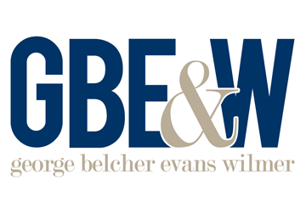
EEOC Issues Resources on Sexual Orientation and Gender Identity
Important Dates
June 15, 2020
On June 15, 2020, the U.S. Supreme Court ruled that employment discrimination based on sexual orientation or gender identity (SOGI) violates Title VII of the federal Civil Right Act (Title VII)
June 15, 2021
The EEOC published new resources to help employers comply with Title VII’s prohibition against SOGI discrimination

On June 15, 2021, the Equal Employment Opportunity Commission (EEOC) issued guidance for employers regarding sexual orientation or gender identity (SOGI) discrimination under federal law.
The new guidance addresses and expands upon the decision in Bostock v. Clayton County, which the U.S. Supreme Court issued exactly one year prior. In that decision, the court held that firing or otherwise discriminating against individuals because of their homosexuality or transgender status violates the prohibition against discrimination based on sex under Title VII of the federal Civil Rights Act, which applies to all employers with 15 or more employees.
The EEOC’s new resources include a webpage, a technical assistance document and a fact sheet on SOGI discrimination. The new webpage also includes links to the existing EEOC publications on related topics, such as facility/bathroom access and guidance for federal employees.
Prohibited Actions
The new EEOC resources clarify, among other things, that employers may not:
- Segregate or otherwise discriminate against employees based on actual or perceived customer or client preferences (such as by keeping LGBTQ+ employees out of public-facing positions or directing them to certain stores or geographic locations);
- Prohibit a transgender person from dressing or presenting consistent with that person’s gender identity;
- Deny an employee equal access to a bathroom, locker room or shower that corresponds to the employee’s gender identity; or
The new guidance aims to help employers comply with Title VII’s prohibition against discrimination based on sexual orientation or gender identity.
Provided to you by George Belcher Evans & Wilmer
- Create or allow a hostile workplace, such as by intentionally and repeatedly using the wrong name or pronoun to refer to a transgender employee.

